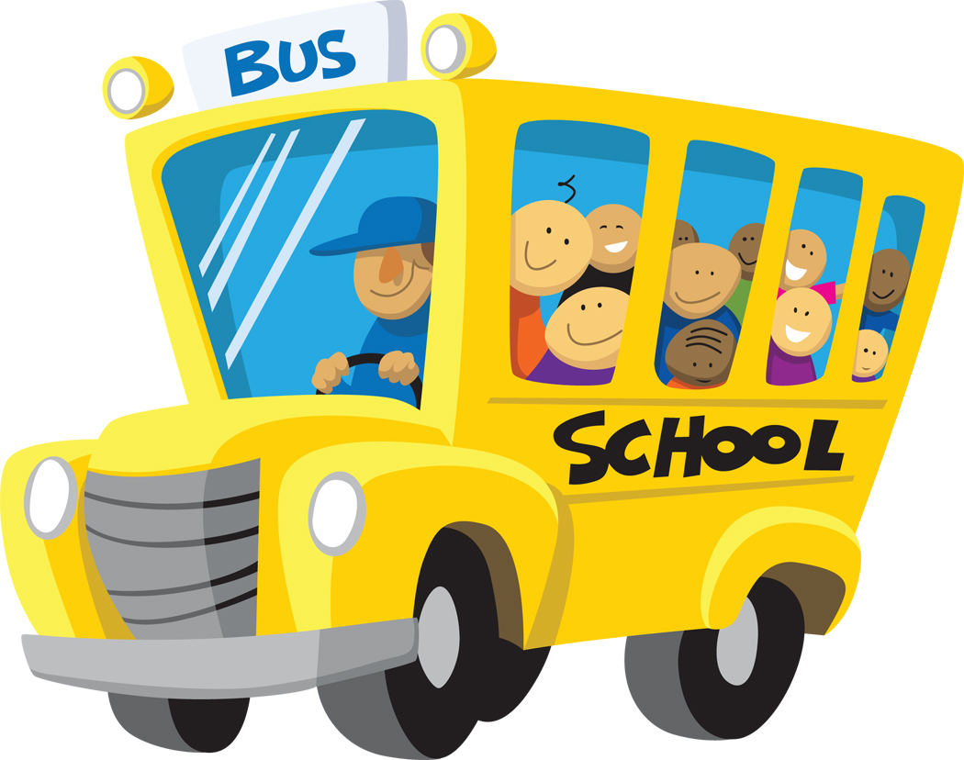
Teachers, Schools, & Learners
Chapter 1 Discussion
“Teaching: Your Chosen Profession”
The reward of teaching is knowing that your life makes a difference.
-William Ayers
- Challenging profession but….
- Effective teachers know why they want to teach
- (See table on page 7)
- Student variability- differences among students in regard to their developmental needs, interests, abilities, and disabilities
- Student diversity – differences among students in regard to gender, race, ethnicity, culture, and socioeconomic status
- What does it mean to be passionate about teaching? – “they possess a variety of schemata for seeing what is important, and they have a broad repertoire of moves with which to quickly and gracefully act on the situation that they see”
- Albert Einstein quote: “Believe it or not…” (page 10)
- Influence of past teachers- may be the principal reason you decided to become a teacher
- Desire to serve – “Very few people go into education to become rich or famous…. Tremendous dedication and concern for others…” (page 10)
- Teach for America program (Wendy Knopp, 1989)
- Practical benefits of teaching- hours, summer, etc.
- Salaries and Benefits
- Cost of living, moonlight, fringe benefits
- Job security and job outlook – tenure (job security granted to teachers after satisfactory performance for a specified period, usually 2-5 years), population of school-age children by 2012 is estimated to be 48.2 million, LOTS of job opportunities over the next 10 years
- Job opportunities for teachers from diverse groups – different races, disabilities
- Consider the challenges as well as the satisfactions: develop your personal philosophy of education and teaching, build a repertoire of teaching strategies, strengthen your leadership skills, acquire a knowledge base of research and theory to guide your actions
- Classroom management – must do this effectively (consistently), develop a leadership plan, create a positive learning environment, and enhance your communication skills
- Increasing school violence: high teacher-student ratio, high student-mobility rate (a high proportion of students move during an academic year)
- Social problems that impact students: poverty, substance abuse, teen pregnancy, homelessness, child abuse and neglect, violence and crime, suicide, other health problems
- Stress increases as the PUBLIC calls on teachers to CORRECT these problems!
- Family and community support – schools, parents, communities all need to work together for children to develop their maximum potential
- Long hours (50+)
- Job stress – teacher burnout
- Professional empowerment – leads to higher morale
- What is it like to be a teacher? – very complex, creative, mental with an inner dialogue
- Six basic realities of teaching:
  - 1. Unpredictable Outcomes- The outcomes of teaching, even in the best of circumstances, are neither predictable nor consistent.
  - 2. Assessing Students’ Learning – It is difficult to assess what students learn as a result of being taught.
  - 3. Limited Influence on Students’ Behavior – The teacher’s ability to influence student behavior is actually quite limited.
  - 4. Importance of Teachers’ Attitudes – With the role of teacher also comes the power to influence others by EXAMPLE!
  - 5. Unpredictability and Immediacy of Teaching- Interactive teaching is characterized by events that are rapid-changing, multidimensional, and fragmented.
  - 6. Uniqueness of Teaching- Teaching involves a unique mode of being between teacher and student – a mode of being that can be experienced but not fully defined or described.
- What society expects – public trust (varies GREATLY), teacher competency and effectiveness (proficient in use of instructional strategies, curriculum materials, advanced educational technology, and classroom management techniques)
- Teacher accountability – understand how backgrounds, attitudes, and learning styles affect achievement
- High-stakes testing, No Child Left Behind, adequate yearly progress (AYP)
- What accomplished teachers do can be described in 5 modes of teaching:
- 1. A Way of Being – you take on the role and let it become a part of you
- 2. A Creative Endeavor – continually shaping and reshaping lessons, events, and experiences of their students
- 3. A Live Performance – it is! Each day is unpredictable!
- 4. A Form of Empowerment – teachers have more influence than students because they establish learning goals, select methods, set the pace, evaluate students’ progress, and decide whether students pass or fail
- 5. An Opportunity to Serve – altruistic dimension of teaching is at the heart of the motivation to teach; the paycheck, the public regard, and the vacations have little holding power compared to the opportunity to serve
- Keepers of the Dream – belief that education can improve the quality of life ☺

You should now be able to answer the following questions:

- Why do I want to teach?
- What challenges will I confront as a teacher?
- What is it like to be a teacher? (a general idea)
- What will society expect of me as a teacher?
- How do accomplished teachers view their work?

Teachers, Schools, & Learners
Chapter 2 Discussion
“Learning to Teach”
- Three kinds of knowledge needed to teach:
- 1. Self-knowledge – effective teachers understand themselves and are sensitive to students’ needs, must be able to tolerate ambiguities and be able to reduce anxiety about being observably effective, loneliness or isolation, need time to interact and observe colleagues
- 2. Knowledge of students- you must know student characteristics such as aptitudes, talents, learning styles, stages of development, and readiness to learn new materials; YOUR expectations will directly affect student achievement
- 3. Knowledge of subject- assumed to be extensive, pedagogical content knowledge (joint product of wisdom about teaching, learning, students, and content
- Using education theory and research – goal is to learn how to apply this knowledge to your own teaching; understand the “why”
- Barak Rosenshine – research on cognitive processing, 6 basic steps:
- 1. Present new material in small steps so that the working memory does not become overloaded
- 2. Help students develop an organization for the new material
- 3. Guide student practice by a) supporting them during initial practice and b) providing extensive student processing
- 4. When teaching higher level tasks, support students by providing them with cognitive strategies
- 5. Help students to use cognitive strategies by providing them with procedural prompts (‘who’, ‘what’, ‘why’, ‘when’) and modeling the use of these
- 6. Provide for extensive student practice
- Importance of reflection, problem-solving orientation to create optimum learning environments for students
- Five views of Teacher Knowledge Base:
- 1. Personal development view “Teachers who appear in charge of their own lives, who radiate power, tranquility, and grace in their actions, are going to command attention and respect. People will follow them…”
- 2. Research-based competencies
- 3. State standards: outcome-based or performance-based teacher education
- 4. Job-analysis approach
- “Star Teachers” – persistence, protecting learners and learning, application of generalizations, approach to students ‘at-risk’, professional vs. personal orientation to students, burnout causes and cures, fallibility, organizational ability, physical/emotional stamina, teaching style, explanation of success, student rapport, readiness to believe that education will provide students with the best chance of “making it”
- National Board for Professional Teaching Standards (NBPTS)
- Interstate New Teacher Assessment and Support Consortium (INTASC) 10 standards on page 51
- Educational reform movement in 1983
- Holmes Group, Professional Development Schools (PDSs)
- Holmes Partnership – NBPTS, National Education Association (NEA), American Federation of Teachers (AFT)
- School-based teacher education – extensive field experiences
- Professional standards boards – many teachers teaching “out-of-field”
- Lessons to learn from observing in classrooms (field experiences) meaningful with focus and conducted with clear purpose – see “motivation” chart on page 55
- Classroom experiences – microteaching, teaching simulations, video cases, practicum, classroom aides, student teaching
- Reflective teaching log (journal) see page 60
- Experience in multicultural settings- different racial and ethnic backgrounds, students with exceptional needs
  - You will be challenged to reach out to all students…. Teach them they are persons of worth and can learn…. Be sensitive to differences while at same time treat them fairly
- Induction programs, internship programs, substitute teaching (270,000 substitutes daily across U.S.)
- Develop a teaching portfolio
- Priceless MENTORS! Mentoring
- Professional Development: self-assessment, in-service workshops, teacher centers, professional developments schools (PDSs), student teachers, becoming a mentor, graduate study, “Professional Opportunities on the Internet” (mylabschool.com)

You should now be able to answer the following questions:

- What knowledge do you need to teach?
- What are five views of the teacher knowledge base?
- How do reforms in teacher education affect you?
- What can you learn from observing in classrooms?
- How can you gain practical experience for becoming a teacher?
- How can you develop your teaching portfolio?
- How can you benefit from mentoring relationships?
- What opportunities for continuing professional development will you have?

Teachers, Schools, & Learners
Chapter 3 Discussion
“Ideas and Events That Have Shaped Education in the United States”
“We educate and we are educated for some purpose we consider good. We teach what we think is a valuable set of ideas. How else could we construct education?” – Nelson, Carlson, & Palonsky

- Events of the past shape the events of the future – we as dedicated, skilled educators must analyze these to evaluate more effectively current proposals for change
- Awareness of ideas and events that have influenced teaching is a hallmark of professionalism
- Considering your personal education philosophy:
  - What should the purposes of education be?
  - What is the nature of knowledge?
  - What values should students adopt?
  - What knowledge is of most worth?
  - How should learning be evaluated?
- Your behavior as a teacher is strongly connected to your beliefs about:
  - Teaching and Learning
  - Students
  - Knowledge
  - What is Worth Knowing
  - Philosophical Areas
- Branches of philosophy:
  - Metaphysics
  - Epistemology
  - Axiology (ethics, aesthetics, logic, Socratic questioning)
  - Deductive thinking (general to specific), inductive thinking (specific to general)
- 5 Modern Philosophical Orientations to Teaching:
  - Perennialism (intellect is the highest priority, Bloom, Hutchins, Adler)
  - Essentialism (basics, Bagley)
  - Progressivism (child-centered, Dewey)
  - Existentialism (individual quest for meaning, it’s about ME, Satre, Greene)
  - Social Reconstructionism (schools should be role models for changing society, tied to Progressivism, Counts)
- Humanistic Psychology – personal freedom and choice, awareness, personal responsibility, individual self-actualization, derived from Humanism
- Behaviorism- desirable human behavior can be product of design (Watson, Skinner, Pavlov)
- Constructivism- uses student-supported learning, student is key to learning
- Schools of Yesterday:
  - American Colonies (1620-1750)
    - Parochial Schools
    - Dame schools
    - Horn Book
    - Reading and Writing Schools
    - Latin Grammar School
    - Massachusetts Act of 1647
    - African-Americans & Native Americans
- Revolutionary Period (1750-1820)
  - Benjamin Franklin
  - English Academies – Sarah Pierce (Female Seminaries)
  - Thomas Jefferson –“Education of the people is the most effective means of preserving liberty.” University of Virginia
  - Noah Webster – Elementary Spelling Book (“The Old Blue Back”), The American Dictionary
- Struggle for State-Supported Schools (1820-1865)
  - Horace Mann (Common Schools, Normal Schools)
  - Catherine Beecher
  - McGuffy Readers (6 in series – hard work, honesty, truth, charity, and obedience)
  - Morrill Land-Grant Act, 1862
- Changes in the Teaching Profession (1865-1920)
  - Attendance Laws
  - Booker T. Washington – belief that education could improve the lives of African-Americans just as whites… “Poverty and ignorance have affected the black man just as they affect the white man. But the day is breaking, and education will bring the complete light…”, Tuskegee Institute (1880)
  - Kindergarten in 1855! -Friedrich Froebel, Margarethe Schurz opened first in her home at Watertown, Wisconsin
  - Professional Teacher Organizations: NEA- National Education Association (1857), AFT- American Federation of Teachers (1916)
- Progressive Era (1920-1945)
  - Progressive Movement – improve the quality of American life, teachers were “guides” not task-masters
  - John Dewey – Laboratory School
  - Maria Montessori – Montessori School
  - Immigrants and Minorities (Native Americans – loss of traditional culture)
- Modern Postwar Era (1945-present)
  - 3 trends: Americanization, Democratization, Professionalization
  - 1950’s – National Defense Education Act of 1958, desegregation, Brown v. Board of Ed of Topeka
  - 1960’s- Kennedy’s high hopes, Teachers were capable professionals! Implementation of curricular changes: open-education movement, team teaching, individualized instruction, integrated-day concept, flexible scheduling, non-graded schools
  - Elementary and Secondary Education Act (1965), allocated funds based on number of poor children in school districts
  - Bilingual Education Act (1968), Title VII
  - 1970’s- Accountability and Equal Opportunity, “back to basics”, Teachers couldn’t be trusted, “Cookbook directions”, Low confidence – BUT this led to… More teachers have advanced training, more high school graduates, better instructional methods to reach diverse learners, more materials available, school buildings improved and better equipped
  - Title IV- Education for All Handicapped Children Act (Public Law 94-142), 1975, mainstreaming
  - 1980’s Great Debate – Teacher bashing – a “nation at-risk”, publications calling for reform (Mortimer Adler, William Bennett)
  - 1990’s –Teachers as LEADERS in the profession, bringing about CHANGE
  - No Child Left Behind Act (2002) REAUTHORIZATION!
__________________________________________________
You should now be able to answer these questions:

- What determines your educational philosophy?
- What are the branches of philosophy?
- What are 5 modern philosophical orientations to teaching?
- What psychological orientations have influenced teaching philosophies?
- How can you develop your own personal educational philosophy?
- What were teaching and schools like in the American colonies? (1620-1750)
- What were goals of teaching during the Revolutionary Period? (1750-1865)
- How was the struggle won for state-supported common schools? (1820-1865)
- How did compulsory education change schools and the teaching profession? (1865-1920)
- What were the aims of education during the Progressive Era? (1920-1945)
- How did education change during the modern postwar era? (1954-present)

Point to remember: Teach for STUDENTS!!! ☺

Teachers, Schools, & Learners
Chapter 4 Discussion
“Social Realities in Today’s Schools”
- Primary purpose of schools: provide students with academic knowledge, be prepared for LIFE beyond school
- Prosocial values (honesty, patriotism, fairness, civility)
- “Education is primary means of producing enlightened citizens.”
- Service learning- opportunities to serve communities
- Magnet schools
- Rural, Suburban, & Urban schools – differences (Need children to recognize self-worth)
- School culture, physical environment, practices of schools (self-contained classrooms, open-spaced classrooms, departmentalization, traditions), classroom culture – up to YOU!
- Successful schools –Achievement= Students are learning to solve problems, think creatively, learning to LEARN!
- School effectiveness:
- Strong leadership
- High expectations
- Emphasis on basic skills
- Orderly school environment
- Frequent, systematic evaluation of student learning
- Sense of purpose (vision of excellence)
- Teachers, administrators, parents, students – ALL WORK TOEGETHER
- At-risk schools and students
  - Almost every community in America – kids are living in a socially toxic environment!
  - Extreme stress, poverty, crime, lack of adult guidance (parenting)
  - High drop-out rates, low grades, perform below grade level, behavior issues, can be older than peers (retention)
  - The South! (chart on page 135)
  - Risk of students lagging behind increases by 2 percentage points for every year in poverty
  - Homeless students
  - Latchkey kids (3-8 p.m.)
  - Substance abuse (drugs and alcohol)
  - Violence, crime, gangs
  - Teen pregnancy
  - Suicide
- School programs for at-risk students
  - Peer counseling/ Peer mediation
  - Full-service community schools
  - Compensatory education programs (Head Start, Success for All, Upward Bound)
  - Alternative school, School-within-a-school, Out-of-school time (OST) activities – extracurricular activities – Right Moves for Youth
- Community Involvement
  - Civic organizations
  - Volunteer mentor programs
  - Corporate education partnerships
  - Before/After school programs
  - Tutors, Lunch buddies, Personal needs (clothing, medical, glasses), Meet family

You should now be able to answer the following questions:

- What is the role of the schools in today’s society?
- How can schools be described?
- What are schools like as social institutions?
- What are the characteristics of successful schools?
- What social problems affect schools and place students at risk?
- How are schools addressing societal problems?
- How can community-based partnerships help students learn?

Chapter 7 Key Terms
“Teaching Diverse Learners”

- Diversity
- Culture
- Cultural identity
- Equal educational opportunity
- Bilingual education
- Limited English proficient (LEP)
- Multiculturalism
- Ethnicity
- Race
- Minorities
- Stereotyping
- Individual racism
- Institutional racism
- Afrocentric schools
- Socioeconomic factors
- Indian Education Act of 1972 (1974 amendments)
- Bicultural
- Monolingual
- Multicultural education
- Multicultural curriculum
- Sex role socialization
- Sex role stereotyping
- Women’s Educational Equity Act of 1974 (WEEA)
- Gender bias
- Gender fair classroom

Chapter 8 Key Terms
“Addressing Individual Learners’ Needs”

- Piaget’s Model of Cognitive Development
(sensorimotor intelligence stage, preoperational thought stage, concrete operational stage, formal operations stage)
- Erikson’s Model of Psychosocial Development
- Psychosocial crisis
- Kohlberg’s Model of Moral Development (Reasoning)
- Character education
- Hierarchy of needs
- Intelligence (and testing)
- Multiple intelligences
- Learning styles
- Exceptional learners
- Students with disabilities
- Learning disability (LD)
- Attention deficit hyperactivity disorder (ADHD)
- Attention deficit disorder (ADD)
- Special education
- Gifted and Talented (TD)
- Laws: Education for All Handicapped Children (PL 94-142), Individuals with Disabilities Education Act (IDEA), 1997 Amendments to IDEA
- Individualized education plan (IEP)
- Mainstreaming
- Inclusion, full inclusion
- Least restrictive environment
- Assistive technology
- Collaborative consultation

Chapter 9 Key Terms
“Authentic Instruction and Curricula for Creating a Community of Learners”

- Classroom climate
- Classroom dynamics – communication skills, student interactions
- Positive learning environment
- Caring classroom
- Classroom organization
- Between-class ability grouping
- Within-class ability grouping
- Cooperative learning
- Authentic learning tasks
- Allocated time
- Time on task
- Academic learning time
- Opportunity to learn (OTL)
- Block scheduling
- Classroom management
- Democratic classrooms
- Choice theory
- Assertive discipline (Lee Cantor)
- Direct instruction
- Mastery learning
- Constructivist teaching
- Modeling
- Scaffolding
- Information processing
- Inquiry learning/discovery learning
- Peer-mediated instruction
- Group investigation
- Peer-tutoring, cross-age tutoring
- Curriculum (explicit, hidden, null, subject-centered, integrated)
- Extracurricular/co-curricular programs
- Tyler rationale

Chapter 6 Key Terms
“Ethical & Legal Issues in U.S. Education”
- code of ethics
- ethical dilemmas
- due process
- nondiscrimination
- teaching contract
- tenure
- dismissal
- collective bargaining
- grievance
- academic freedom
- tort liability
- negligence
- educational malpractice
- copyright laws
- fair use
- Digital Millennium Copyright Act (DMCA)
- Freedom of expression
- Censorship
- Search and seizure
- Buckley Amendment
- Corporal punishment
- Sexual harassment

Chapter 13 Key Terms
“Your Induction into Teaching”
- Teaching certificate
- National Council for Accreditation of Teacher Education (NCATE)
- Recertification
- National Association of State Directors of Teacher Education and Certification’s Interstate Agreement (NASDTEC)
- Charter
- Alternative certification
- Emergency certification
- Praxis Series: Professional Assessments for Beginning Teachers (praxis – putting theory into practice)
- Teacher supply and demand
- Placement service
- Credentials file
- Resume
- Letter of inquiry
- Letter of application
- Collegiality
- Collaboration
- Peer coaching
- Team teaching
- Collegial support team (CST)
- Co-teaching
- Quantitative evaluation v. Qualitative evaluation
- Clinical supervision

