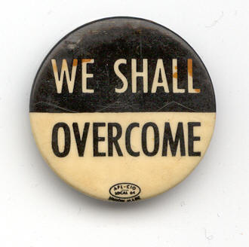

Exploring the Civil Rights Movement

A Multi-Text Study of

The Watsons Go to Birmingham –1963
by Christopher Paul Curtis
And
Freedom on the Menu: The Greensboro Sit-Ins
by Carole Boston Weatherford

Jessica C. Epley

Multi-text Study:

“The Watsons Go to Birmingham – 1963”

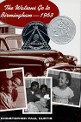

By Christopher Paul Curtis

“Freedom on the Menu: The Greensboro Sit-Ins”

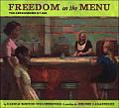

By Carole Boston Weatherford

Jessica C. Epley
April 4, 2006

Table of Contents

Table of Contents III
Rationale for Multi-Text Study V
Suggestions for Interdisciplinary Connections VII
Suggestions for Post-Reading Projects IX
North Carolina Standard Course of Study XI
References XV
Student Packet 17
Table of Contents 2
Student Packet Rubric 4
Text and Author Information: The Watsons Go to Birmingham 5
Text and Author Information: Freedom on the Menu 5
Pre-Reading Internet Workshop: Culture of the 60’s 6
Website Evaluation Worksheet 7
Vocabulary List 8
Reading Activities: Chapters 1 and 2 9
Discussion/Journaling Questions: 9
Writing Activity: Humor as a Literary Element 9
Writing Activity: Comparing the Watson Children 9
Reading Activities: Chapters 3 and 4 12
Discussion/Journaling Questions: 12
Dialect Awareness 12
Simile Study 12
Reading Activities: Chapters 5 and 6 13
Discussion/Journaling Questions: 13
Exploring Characterization 13
Reading Activities: Chapters 7 and 8 14
Discussion/Journaling Questions: 14
Literary Element: Dialogue 14
Reading Activities: Chapters 9 and 10 15
Discussion/Journaling Questions: 15
Art Activity: Travel Brochure 15
Freedom on the Menu: The Greensboro Sit-ins 16
Recognizing Bias & Propaganda in the Media 16
Recognizing Bias and Propaganda in the Media Worksheet 17
Reading Activities: Chapters 11 and 12 18
Discussion/Journaling Questions: 18
Open Mind Activity 18
Reading Activities: Chapters 13 and 14 20
Discussion/Journaling Questions: 20
The Birmingham Church Bombing: KWL Activity 21
Internet Workshop: The Birmingham Church Bombing 22
Human Rights Activity 24
Writing Activity: Universal Declaration of Human Rights Vs. Bill of Rights 35
Current Events Writing Activity: Human Rights Watch 35
Reading Activities: Chapter 15 and Epilogue 36
Discussion/Journaling Questions: 36
Interview the Watsons 36
Self-Assessment 36
Post-Reading Activity: Extension Project 37
Extension Project Rubric 40
Final Multi-Text Study Assessment 41
Additional Reading Selections 45
After-Reading Survey 47

Rationale for Multi-Text Study

The focus novel of this multi-text study is The Watsons Go to Birmingham –1963 by Christopher Paul Curtis, winner of the 1996 Newberry Honor Award and the 1996 Coretta Scott King Honor. I was first introduced to this book in Mr. Mac Frazier’s seventh-grade Language Arts class at Liberty Middle School in 2004, and I was instantly won over by the story and the writing style of Christopher Paul Curtis. This novel is an appropriate focus of a multi-text study for several reasons. First, the novel is historically based. Second, the author’s writing genius provides opportunities for students to reflect upon sensitive topics in a non-threatening manner. Finally, the novel uses universal themes that most, if not all, students can relate to in some fashion. The effects of racism and prejudice, the complexity of family and friendship, and the emotional difficulty of loss and grief are universal themes found in this novel.
The companion text is Freedom on the Menu: The Greensboro Sit-Ins by Carole Boston Weatherford. This book is an introductory text to the civil rights movement on a more regional level. While the focus novel examines the civil rights movement in general, this text provides a focus on the civil rights movement in North Carolina. I chose this book because it is simple, yet thought provoking. This book would be appropriate for a read-aloud and the author captures both the innocence of children and the complexity of adulthood that marked the African American struggle for equality during civil rights movement.
As a result of reading The Watsons Go to Birmingham –1963 and Freedom on the Menu: The Greensboro Sit-Ins and participating in the activities in the complementary student packet, students will gain a better understanding of the United States and North Carolina before, during, and after the civil rights movement. Students will also develop a deeper appreciation for African American heritage and be able to apply moral and ethical assessments to both historical and present-day events.
 | Publisher’s Recommended Reading Level
The Watsons Go to Birmingham –1963  Christopher Paul Curtis  Dell Laurel-Leaf Books, New York. 1995 | Grade 9-12 Grade
Freedom on the Menu: The Greensboro Sit-Ins  Carole Boston Weatherford  Paintings by Jerome Lagarrigue  Dial Books for Young Readers, New York. 2005 | Age 5-8

Suggestions for Interdisciplinary Connections

Due to time constraints, I am only able to include a limited number of interdisciplinary connection activities in the student packet. There are many great activities listed below that I wanted to make available for reference.
History

- Life in 1963 was quite different for African Americans than it is today, especially in the South. The '60s were turbulent times in America. After reading the novel, have students find inferences that blacks and whites were treated differently (pages 5-6). Check reference books in the school media center for historical details of the Birmingham church bombing and look for the names of the young girls listed on the “In Memory of” page. Probe the question raised by Kenny (p. 199), “Why would they hurt some little kids like that?” Have students create a class book on What America Was Like When the Watsons Went to Birmingham in 1963.

- Using the library, Internet, and other resources, students may research the actual Birmingham church bombings and create their own news reports (newspaper, television, radio) giving the facts of the horrible event.

- Students may interview parents, grandparents, neighbors, or teachers who remember the era of the Civil Rights Movement. Results of the interviews may be presented in written and/or oral reports.

- The Watsons' journey takes them down Interstate 75 from Flint, Michigan, to Birmingham, Alabama. As the students read the book, a class wall map can be used to chart the progress of the Watsons during their travels. Cooperative groups of students could be assigned states that lie on the travel route. As the Watsons enter each of the states, student groups could report on the interesting sites encountered along I-75, as well as the important facts of each of the states (capitol, major cities, etc.).
Language Arts

- To explore characterization in the novel, students may choose one of the characters from the novel and create a safety deposit box, hope chest, or just a place where that character stores things that are important to him/her. This box should include objects/artifacts that will reveal what the character is like. For example, in Byron's box students may want to include a mirror, a comb, etc. to symbolize his obsession with his appearance and his vanity.

- Important to the study of literature is the opportunity for readers to reflect and respond about what they have read. Reader Response Journals, Reader's Logs, and Literature Logs offer students the opportunity to make personal connections with the book as they read. Dialogue Journals may also be used, providing students a forum to interact in writing with other classmates and/or the teacher about the book.

Science

- Throughout the novel there is a continuous discussion among family members about the merits of Michigan and Birmingham winters. As the novel opens, Kenny describes the day as being “a zillion degrees below zero” (p. 1). In a funny episode, Byron gets his lips stuck to the side-view mirror of the car in subzero weather. Discuss what could have caused Byron’s lips to stick to the mirror. How does skin freeze to ice? Have a dialogue with students about some of the properties of water–i.e., its freezing point being 320 F (00 C) and its expansion as it freezes. Have students conduct the following simple activities:
The Sticking Ice Tray–Needed: a tray of ice just out of the freezer. Note that the tray will stick to your fingers. Here’s why: If the tray and ice cubes are below the freezing point of water, the warmth of the hand will melt a thin layer of frost. Then, as the hand is cooled, the layer of water will freeze again. It is possible that the hand or finger can freeze so tightly to the tray that a little skin is torn as it is pulled loose.
Freeze with Fingers–Needed: two ice cubes. Press the cubes together, one flat surface tightly against the other. They will freeze together. Here’s why: The increase in pressure lowers the melting point and some of the ice melts where they are in contact; then the water freezes again as the pressure is reduced.

Math

- Momma has researched their trip to Birmingham from Flint. Students can reproduce her calculations including the mileage between stops (ties in with the geography/map activity), speed they will travel, etc. Teachers may develop word problems including travel time, distance, expenses, etc. After they have developed their word problems, students can give them to classmates to solve.

Suggestions for Post-Reading Projects

Below are additional post-reading activities that may be useful in this novel study. Due to time constraints it is not possible to include all these activities in the student packet, but you may find them to be a useful reference tool.

- This book is set in 1963, both in Flint, MI and Birmingham, AL. How would the story be different if it were set today, in your own hometown and one you are not familiar with? (Choose a city you know nothing about it, research it, and then include it as part of the setting). How have things changed since the 1960s? Write an essay in which you address these questions.

- Imagine that MGM has decided to make a movie version of The Watsons. You have been named the casting director and have the power to decide who will play each of the roles. You may use famous movie stars as well as members of this class in the picture. Who will you cast in each of the major roles? You must explain your choices. Then, create a movie poster for the film.

- Imagine that you are a talk show host. You have invited members of the Watson family to be your guests. Plan the show. What is the theme of this episode? Which characters will you invite to be your guests? With a partner (or partners), plan and conduct your interview. Record the interview on audiocassette.

- The Watsons traveled over 100 miles from Flint to Birmingham. Plan an excursion for today, following the same route. Make a travel brochure for your trip. Make it sound as exciting as possible. Plan your own itinerary for this trip. What interesting places might you stop along the way? Do some research using the Internet to discover what sightseeing you might like to do on this trip.

- Work with a team to create a mural highlighting your favorite scenes in The Watsons, or build a mobile representing the main characters of the novel. The mobile could include things cut from magazines or your own drawings, or items that represent the character you are portraying.

- Write and illustrate a version of The Watsons for younger children to read. Be sure to tell the important things from the story, and capture each of the main characters' personalities. You could also create a comic book version of the book.

- The novel contains a great deal of regional expressions. Class discussions may include examination of unfamiliar terms and phrases. Students can use context clues in conjunction with a dictionary of regional sayings to discover the meanings of unfamiliar words and expressions. (As a follow-up activity, students could interview a speaker who uses some of these regionalisms and/or create a dictionary of expressions they use.)

http://scholar.lib.vt.edu/ejournals/ALAN/winter99/george.html

- Prepare a news broadcast from the scene of the church bombing in Birmingham. Write a scrip and be prepared to act it out. Interview both African American and white bystanders for their reactions. (Individual or pair)

- Prepare a sales campaign extolling virtues of the car the Watsons drive to Birmingham. Look up the statistics - horsepower, gas mileage, engine, etc. What other cars were on the road at the time? Put your ad campaign on a presentation board. (Individual or pair)

- You are a social worker who has been called in because a neighbor complained about Byron and his activities. Fill out a report on him, and discuss the probable options if he continues making the same types of choices in life. (Individual)

- Write and illustrate two-three page diary entry that Rufus might have written after his first week in the new school. (Individual)

- Write a two page internal monologue that Kenny might have while he is behind the couch. (Individual)

- Find a song with a similar theme to one of the ones we identified in The Watsons. Write out the lyrics and discuss the similarities and differences between the song and the book.

http://gretchenle.com/online_units/watsons/watson1.html

North Carolina Standard Course of Study
Compliance Chart

UNIT ACTIVITY | NC LANGUAGE ARTS GRADE 7
Pre-Reading Internet Workshop  Students individually conduct research on the Internet working from a predetermined list of internet sites to compile and analyze information on American culture in the 1960’s. | 2.01 Respond to informational materials that are read, heard, or viewed by summarizing information, making connections to related topics/information, drawing inferences and conclusions, and generating questions.
Writing Activity: Humor as a Literary Element  Students individually recall how Christopher Paul Curtis uses humor to tell Kenny’s story. Drawing from Curtis’ example, students will write additional scenes or passages to include in the storyline of The Watsons Go to Birmingham. | 1.02 Respond to expressive materials that are read, heard, or viewed by determining the importance of literary effects on the reader/viewer/listener.
Writing Activity: Comparing the Watson Children  Students individually compare and contrast the Watson children using a triple Venn diagram and then compare their sibling relationships with those of the Watson children. | 1.02 Respond to expressive materials that are read, heard, or viewed by comparing and contrasting information.  5.01 Increase fluency, comprehension, and insight through a meaningful and comprehensive literacy program by analyzing the connections of relationships between and among characters, ideas, concepts, or experiences.
Dialect Awareness Discussion  Students refine their understanding of dialect as a literary element by comparing and contrasting standard English and a regional dialect and by participating in a group discussion. | 1.02 Respond to expressive materials that are read, heard, or viewed by determining the importance of literary effects on the reader/viewer/listener.  6.01 Model an understanding of conventional written and spoken expression by determining when and where dialects and standard/nonstandard English usage are appropriate.
Simile Study  Students respond to similes as a literary element by writing similes of their own. | 6.01 Model an understanding of conventional written and spoken expression by experimenting with figurative language and speech patterns.
Exploring Characterization  Students individually chart the characteristics of the main characters of The Watsons go to Birmingham by direct observation and making inferences from the text. | 5.01 Increase fluency, comprehension, and insight through a meaningful and comprehensive literacy program by analyzing the effects of such as elements as plot, theme, point of view, characterization, mood, and style.
Literary Element: Dialogue  Students individually define how dialogue affects written expression and analyze the relationship between dialogue and characterization. | 5.01 Increase fluency, comprehension, and insight through a meaningful and comprehensive literacy program by analyzing the effects on texts of such literary devices as figurative language, dialogue, flashback, allusion, and irony.
Art Activity: Travel Brochure  Students individually produce an artistic product that persuades travelers to navigate between Michigan and Alabama using informational sources and the Internet. | 2.02 Use multiple sources of print and non-print information in designing and developing informational materials (such as brochures, newsletters, and infomercials) through identifying and using appropriate primary and secondary sources.
Freedom on the Menu: The Greensboro Sit-Ins  Students individually read newspaper articles and editorials related to the civil rights movement in North Carolina and particularly to the Greensboro Sit-Ins. They will recognize bias and propaganda in journalism. This activity arises from Freedom on the Menu: The Greensboro Sit-Ins by Carole B. Weatherford. | 3.01 Explore and analyze argumentative works that are read, heard, or viewed by recognizing bias, emotional factors, or semantic slanting.
Open Mind Activity  Students individually produce artistic expressions of how they interpret characters’ mental/emotional state after arriving in Alabama and participate in a group discussion about their artifacts. | 1.02 Respond to expressive materials that are read, heard, or viewed by drawing inferences or conclusions and by creating an artistic interpretation that connects self and/or society to the selection.
KWL Activity  Students individually question their own knowledge about the Birmingham church bombing and explore questions they would like to answer. | 1.02 Respond to expressive materials that are read, heard, or viewed by making connections between works, self, and related topics.
Birmingham Church Bombing Internet Workshop  Students work individually to learn about the Birmingham church bombing and produce a press release detailing the event. | 2.01 Respond to informational materials that are read, heard, or viewed by summarizing information and determining the importance of information.  4.01 analyze the purpose of the author or creator by examining any bias, apparent or hidden messages, emotional factors, and/or propaganda techniques.  6.01 Model an understanding of conventional written and spoken expression by using a variety of sentences correctly, punctuating them properly, and avoiding fragments and run-ons.
Interview the Watsons  Students work in small groups, assuming the roles of interviewer and characters from the novel, to produce a skit. | - Narrate an expressive account that  engages the reader/listener by establishing a context and creating a point of view.  4.03 Develop the stance of a critic by considering and presenting alternative points of view or reasons.  5.01 Increase fluency, comprehension, and insight through a meaningful and comprehensive literacy program by engaging in small group discussions.  6.01 Model an understanding of conventional written and spoken expression by choosing language that is precise, engaging, and well suited to the topic and audience and by applying language conventions and usage during oral presentations.
Extension Project  Students work in small groups to develop a comprehensive final product that creatively details the Watsons’ trip from Michigan to Alabama and includes the Birmingham church bombing. | 1.02 Respond to expressive materials that are read, heard, or viewed by creating an artistic interpretation that connects self or society to the selection.  2.01 Respond to informational materials that are read, heard, or viewed by determining the importance of information and summarizing information.  2.02 Use multiple sources of print and non-print information in designing and developing informational materials (such as brochures, newsletters, and infomercials) through comparing, contrasting, and evaluating information from different sources about the same topic.  4.01 Analyze the purpose of the author or creator by examining any bias, apparent or hidden messages, emotional factors, and/or propaganda techniques.  6.01 Model an understanding of conventional written and spoken expression by applying language conventions and usage during oral presentations.  6.02 Continue to identify and edit errors in spoken and written English by producing final drafts/presentations that demonstrate accurate spelling and the correct use of punctuation, capitalization, and format.
Vocabulary  Students individually compile, define, use, and demonstrate their understanding of vocabulary from The Watsons go to Birmingham and Freedom on the Menu: The Greensboro Sit-Ins. | 6.01 Model an understanding of conventional written and spoken expression by extending vocabulary knowledge by learning and using new words and by determining the meaning of unfamiliar vocabulary words using context clues, a dictionary, a glossary, a thesaurus, and structural analysis (roots, prefixes, suffixes) of words.
Discussion/Journaling  Depending on which approach is taken, students will either engage in whole group or small group discussions concerning topics that arise from The Watsons Go to Birmingham and Freedom on the Menu: The Greensboro Sit-Ins. In the alternative, students will respond to discussion questions in a journaling fashion. The two approaches may be combined to reflect some group participation in conjunction with personal reflection through journaling. | 1.01 Narrate an expressive account that engages the reader/listener by establishing a context and creating a point of view.  5.01 Increase fluency, comprehension, and insight through a meaningful and comprehensive literacy program by engaging in small group discussions and taking an active role in whole class seminars.

References

There are many informative print texts and Internet sites related to The Watsons Go to Birmingham, the Greensboro Sit-Ins, the civil rights movement, and American culture during the 1960’s. This reference list includes the best sources I either used or located in connection to this multi-text study.

"Bringing The Watsons Go to Birmingham, 1963 to the Middle School Classroom." The ALAN Review, Volume 26, Number 2. http://scholar.lib.vt.edu/ejournals/ALAN/winter99/george.html

Comprehensive lesson plans that include discussion questions and suggestions for addressing literary elements in The Watsons Go to Birmingham. http://www.planetbookclub.com/kids/archive/watsons2.00/watsonsintro.html

Search engine that provides video, audio, image, text searches on any topic:
http://www.city.net/countries/united_states/alabama/birmingham/
Interdisciplinary connections and thematic connections: http://www.randomhouse.com/teachers/catalog/display.pperl?isbn=9780385321754&view=tg

Free at Last: The Story of Martin Luther King, Jr. Edited by Penny Smith and illustrated by Christ Forsey. Dorling Kindersley Publishing, New York. 2000

Eye on the Prize: America’s Civil Rights Years, 1954-1965. Juan Williams. Viking Penguin Inc., New York. 1987

Pre-reading and post-reading activities for The Watsons Go to Birmingham:
http://gretchenle.com/online_units/watsons/watson1.html

Author and text information on The Watsons Go to Birmingham: http://scholar.lib.vt.edu/ejournals/ALAN/winter99/george.html;
http://www.kidsreads.com/authors/au-curtis-christopher-paul.asp;

Author and text information on Freedom on the Menu: The Greensboro Sit-Ins:
http://www.powells.com/biblio/0803728603

Child-friendly websites related to American culture in the 1960’s:
1960's Flashback: http://www.1960sflashback.com/
American Cultural History - 1960's: http://kclibrary.nhmccd.edu/decade60.html
I Love the Sixties: http://www.bbc.co.uk/cult/ilove/years/60sindex.shtml
Welcome to the 1960's: http://www2.lhric.org/pocantico/century/1960s.htm
1960's a Go-Go: http://archives.cbc.ca/IDD-1-69-1587/life_society/60s/
Film History of the 1960's: http://www.filmsite.org/60sintro.html

Forms, graphic organizers, and rubrics:
http://school.discovery.com/schrockguide/evalmidd.html
www.freeology.com
http://rubistar.4teachers.org/index.php?screen=ShowRubric&rubric_id=1227250&

Information related to the 1963 Birmingham church bombing:
Dudley Randall’s “Ballad of Birmingham” http://webinstituteforteachers.org/~vfjohnson/ballbham.html
In Memory of Four Little Girls
http://www.useekufind.com/peace/
The "Four Little Girls" Movie Website
http://www.4littlegirls.com/
Historic Places of the Civil Rights Movement
http://www.cr.nps.gov/nr/travel/civilrights/
History Learning Site
http://www.historylearningsite.co.uk/birmingham.htm
Alabama Department of History
http://www.archives.state.al.us/teacher/rights/rights3.html
The16th Street Baptist Church Bombing http://afroamhistory.about.com/library/weekly/aa051401a.htm

Information related to the civil rights movement:
Washington Post Newspaper Article
http://www.washingtonpost.com/wp-srv/national/longterm/churches/archives1.htm
The Martin Luther King Home Page
http://seattletimes.nwsource.com/mlk/index.html
National Civil Rights Museum
http://www.civilrightsmuseum.org/gallery/movement.asp
Western Michigan University's Timeline of the American Civil Rights Movement http://www.wmich.edu/politics/mlk/
The "Powerful Days in Black and White" Photo Exhibit
http://www.kodak.com/US/en/corp/features/moore/mooreIndex.shtml

Multi-Text Study

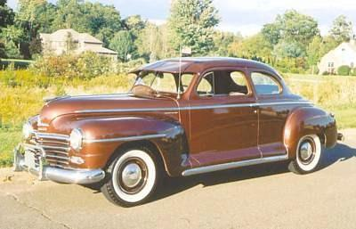

The Watsons Go to Birmingham –1963
By Christopher Paul Curtis

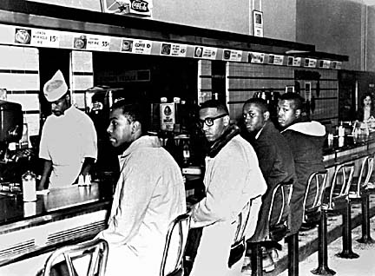

Freedom on the Menu: The Greensboro Sit-Ins
By Carole Boston Weatherford

“They are the boys and girls, the women and men who have seen that things are wrong and have not been afraid to ask ‘Why can’t we change this?’” (Curtis 210).

Student Packet

Name: ___________________________________

Table of Contents

Table of Contents 2
Student Packet Rubric 4
Text and Author Information: The Watsons Go to Birmingham 5
Text and Author Information: Freedom on the Menu 5
Pre-Reading Internet Workshop: Culture of the 60’s 6
Website Evaluation Worksheet 7
Vocabulary List 8
Reading Activities: Chapters 1 and 2 9
Discussion/Journaling Questions: 9
Writing Activity: Humor as a Literary Element 9
Writing Activity: Comparing the Watson Children 9
Reading Activities: Chapters 3 and 4 12
Discussion/Journaling Questions: 12
Dialect Awareness 12
Simile Study 12
Reading Activities: Chapters 5 and 6 13
Discussion/Journaling Questions: 13
Exploring Characterization 13
Reading Activities: Chapters 7 and 8 14
Discussion/Journaling Questions: 14
Literary Element: Dialogue 14
Reading Activities: Chapters 9 and 10 15
Discussion/Journaling Questions: 15
Art Activity: Travel Brochure 15
Freedom on the Menu: The Greensboro Sit-ins 16
Recognizing Bias & Propaganda in the Media 16
Recognizing Bias and Propaganda in the Media Worksheet 17
Reading Activities: Chapters 11 and 12 18
Discussion/Journaling Questions: 18
Open Mind Activity 18
Reading Activities: Chapters 13 and 14 20
Discussion/Journaling Questions: 20
The Birmingham Church Bombing: KWL Activity 21
Internet Workshop: The Birmingham Church Bombing 22
Human Rights Activity 24
Writing Activity: Universal Declaration of Human Rights Vs. Bill of Rights 35
Current Events Writing Activity: Human Rights Watch 35
Reading Activities: Chapter 15 and Epilogue 36
Discussion/Journaling Questions: 36
Interview the Watsons 36
Self-Assessment 36
Post-Reading Activity: Extension Project 37
Extension Project Rubric 40
Final Multi-Text Study Assessment 41
Additional Reading Selections 45
After-Reading Survey 47

Student Packet Rubric

Activity | Possible Points | Self Evaluation | Teacher Evaluation
Pre-Reading  Internet Workshop | 20
Dialect Awareness Discussion Participation | 5
Art Activity:  Travel Brochure | 16
Recognizing Bias and Propaganda in the Media | 6
Birmingham Church Bombing Internet Workshop | 6
Writing Activity: Human Rights | 12
Interview the Watsons | 25
Extension Project | 100
Final  Multi-Text Assessment | 100
Total | 300

300-250 | 249-200 | 199-150 | Below 149
A | B | C | Work in Progress

Text and Author Information: The Watsons Go to Birmingham
The Watsons Go to Birmingham – 1963 by Christopher Paul Curtis is the story of 10 year-old Kenny Watson. The story takes readers from a safe-haven in Flint, Michigan to a world turned inside out in race-torn Birmingham, Alabama. As the Watsons drive South, with "Yakkity Yak, Don't Talk Back" blaring from the stereo, Kenny, brother Byron, and sister Joetta are blissfully unaware of the knowledge that Momma and Daddy possess about the racial tensions in the South. As the kids dream about the next stop in their adventure and meeting a grandmother who speaks a different language (Southern), their parents whisper about unrest and worry about violence. http://scholar.lib.vt.edu/ejournals/ALAN/winter99/george.html

Christopher Paul Curtis grew up in Flint, Michigan. After high school, he worked for thirteen years on the assembly line at the Fisher Body Plant. With his wife's encouragement, Curtis took a year off to finish the book and was eventually able to leave his job at the plant for good. Soon after THE WATSONS GO TO BIRMINGHAM-1963 was published in 1995, it won two of the most prestigious awards in children's literature - a Newberry Honor and a Coretta Scott King Honor. http://www.kidsreads.com/authors/au-curtis-christopher-paul.asp

Text and Author Information: Freedom on the Menu
In 1960, four young black men sat down at a segregated Greensboro, N.C., Woolworth lunch counter and asked to be served, sparking a seven-month long protest in that city and inspiring sit-ins throughout the South. As a prelude, narrator Connie explains that she and her mother would often stop for a snack at the five-and-dime store, standing up as they sipped their sodas 'because we weren't allowed to sit at the lunch counter.' http://www.powells.com/biblio/0803728603

Carole Boston Weatherford is a poet and journalist. She grew up in Baltimore, Maryland, and now lives in High Point, North Carolina, with her husband and their two children.

Pre-Reading Internet Workshop: Culture of the 60’s
(Individual and Group Activity)

The Watsons Go to Birmingham is set in 1963. Choose two of the following Websites to learn about American culture in the 60’s. Complete the following chart. Partner with a classmate to compare information and discuss what you found interesting. Also, individually complete the Website review form on the following page for each Website you visit. Be prepared to share what you have learned. This activity is worth 20 points.

1960's Flashback: http://www.1960sflashback.com/
American Cultural History - 1960's: http://kclibrary.nhmccd.edu/decade60.html
I Love the Sixties: http://www.bbc.co.uk/cult/ilove/years/60sindex.shtml
Welcome to the 1960's: http://www2.lhric.org/pocantico/century/1960s.htm
1960's a Go-Go: http://archives.cbc.ca/IDD-1-69-1587/life_society/60s/
Film History of the 1960's: http://www.filmsite.org/60sintro.html
WebQuest: 1960's Museum: http://school.discovery.com/schrockguide/museum/webquest.html
1960 - 1969: http://history1900s.about.com/od/1960s/

Who was President of the United States in ’63?
What was the minimum wage in ’63?

What were a couple popular movies or television show?
What music was popular?

Describe the fashions of the 60’s.

What were the major news headlines?

What were some of the “firsts” from the 60’s?
(Hint: use the Film History Website)
Additional information:

Website Evaluation Worksheet

What Web browser are you using?

What is the URL of the Web page you are evaluating? | http://
What is the name of the site?

When was the site last updated?

Are the pictures helpful? | Yes | No
Does the title of the page tell you what it is about? | Yes | No
Does the page lead you to other informative links? | Yes | No
Does the author present information you disagree with? | Yes | No
Does the author present information you think is factually wrong? | Yes | No
Does the information contradict information you found elsewhere? | Yes | No
Would you recommend this Website? If not, explain why at the bottom of the page. | Yes | No

Vocabulary List
(Individual Activity)

This is the vocabulary list for the first half of The Watsons go to Birmingham. This vocabulary list should be revisited regularly during this novel study. You will be tested on these vocabulary words at the end of this novel study. Use the bottom of this page to write any words that you would like to add to your personal vocabulary list.

CIVIL RIGHTS MOVEMENT

ULTRA-GLIDE

EQUALITY

FIRST STREET BAPTIST CHURCH

BULLYING

MARTIN LUTHER KING, JR.

BOYCOTT

HERO

PROTEST

PREJUDICE

AFRICAN AMERICAN

NAACP

RESISTANCE

ROSA PARKS

Reading Activities: Chapters 1 and 2

Discussion/Journaling Questions:
(Individual or Group Activity)

- What are the Watsons like? Do you think they’re “weird?”
- Describe Kenny’s relationship with Bryon. Do real brothers act this way?
- Do you predict that the new kid at school will “save” Kenny? Why?
http://www.planetbookclub.com/kids/archive/watsons2.00/watsonsintro.html

Writing Activity: Humor as a Literary Element
(Individual and Small Group Activity)

Humor is woven throughout the book. Examples include Byron's lips getting stuck to the side mirror of the car (pages 12-14), Daniel mimicking Moses Henderson (pages 4-5), and Byron's frozen people story (pages 51-54).

DIRECTIONS: Reread what you think is the funniest passage. Then write a funny passage they would like to add to this novel. Be prepared to share in small groups. Artwork can be added and pages laminated and bound into a book. http://www.randomhouse.com/teachers/catalog/display.pperl?isbn=9780385321754&view=tg

Writing Activity: Comparing the Watson Children
(Individual Activity)
DIRECTIONS: Compare and contrast the three Watson children by using the triple Venn diagram. How would you describe their relationships? Think about your own sibling relationships and compare them to the ones depicted in the novel using the double Venn diagram. http://www.randomhouse.com/teachers/catalog/display.pperl?isbn=9780385321754&view=tg

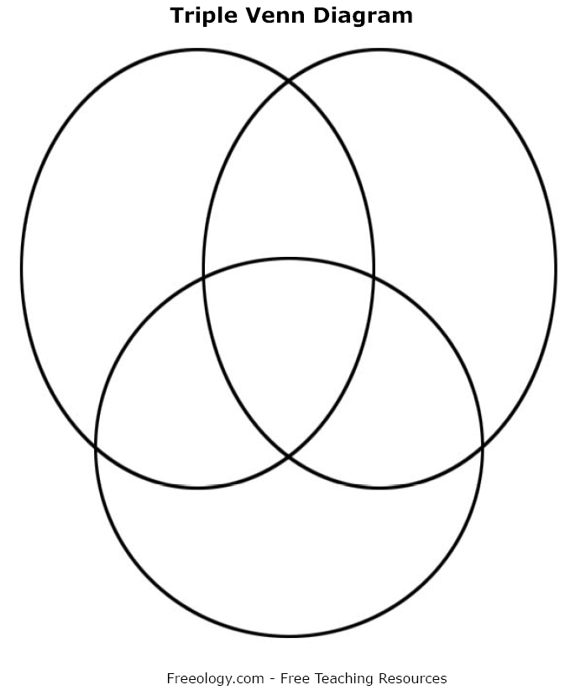

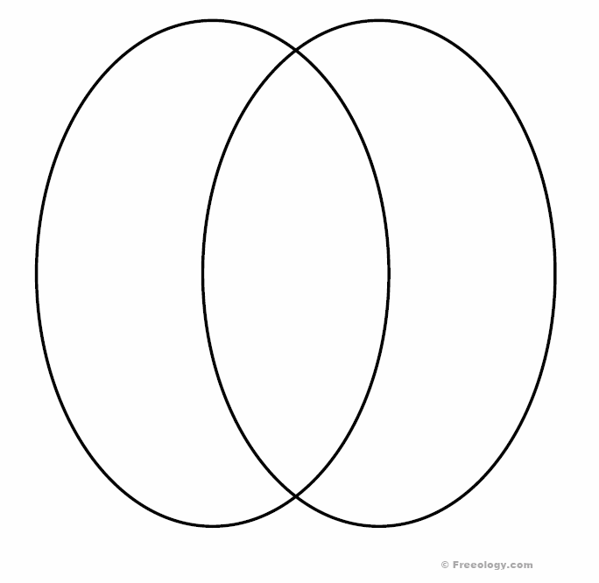

Reading Activities: Chapters 3 and 4

Discussion/Journaling Questions:
(Individual or Group Activity)

- Did any of the events in Chapter 3 make you laugh? Which ones? Why?
- What do you think of the way Rufus and Cody are treated at Kenny’s school?
- Would Rufus and Cody fit in at your school? Why?
- What do you think Momma said to Rufus?
- Do you think it was good for Bryon to tell Joey the story about the “froze-up Southern folks?” Why?
- What do you think of Bryon’s beating up Larry? Did Larry deserve it? Why?
http://www.planetbookclub.com/kids/archive/watsons2.00/watsonsintro.html

Dialect Awareness
(Individual and Small Group Activity)

DIRECTIONS: Think about how Christopher Paul Curtis uses dialect in The Watsons Go to Birmingham. Would the writing be authentic without the use of dialect? Read aloud two poems by Paul Laurence Dunbar, “We Wear the Mask” and “When Malindy Sings” available online at www.poets.org. Open a group discussion by asking “Would the writing be as authentic without the use of dialect?” Participation is worth 5 points.

Simile Study
(Individual Activity)

Christopher Paul Curtis artfully uses similes to bring his words to vivid images for the reader.
DIRECTIONS: Complete the following sentences. (http://www.geocities.com/SoHo/Workshop/8405/watsonsimiles.htm)

1. Screaming like…

2. Feeling like…

3. Dancing like…

4. Stupid as...

5. Erupted like...

6. His eyes are like...

7. The water was as cold as...

8. Boring as...

Reading Activities: Chapters 5 and 6

Discussion/Journaling Questions:
(Individual or Group Activity)

- What do you think of Momma’s way of punishing Bryon for playing with matches?
- Compare and contrast Bryon and Momma.
- Why is Bryon angry with Momma over the welfare food? Is this fair of him?
- Why does Bryon get sick after hitting the bird?
http://www.planetbookclub.com/kids/archive/watsons2.00/watsonsintro.html

Exploring Characterization
(Individual Activity)

DIRECTIONS: Think about how Daddy, Momma, Bryon, Kenny, and Joey are characterized in the novel. Complete following characterization charts for each main character. Below is a sample chart available online from freeology.com.

Character under Evaluation: ____________________________________

Ways character is revealed | Example | What you learned about the character from this example
Character’s speech

Character’s appearance

How other characters feel about the character and react to him/her

Character’s actions

Reading Activities: Chapters 7 and 8

Discussion/Journaling Questions:
(Individual or Group Activity)

- Why are Momma and Dad so angry about Bryon’s hair?
- Do you think that Dad’s punishment of Byron is fair? Why?
- How does Kenny feel about what happens to Bryon? How does Bryon feel about it?
- What do you predict will happen as a result of Bryon’s Latest Adventure?
- Would you like to join the Watsons’ conversations about the Ultra-Glide? Why?
- How do you think Momma really feels about the Ultra-Glide?
- Were you surprised about Momma and Dad’s plan for Bryon? Do you think it will work? Why?
http://www.planetbookclub.com/kids/archive/watsons2.00/watsonsintro.html

Literary Element: Dialogue
(Individual Activity)

DIRECTIONS: After reading Chapter 8 of The Watsons Go to Birmingham think about how the author uses dialogue. Complete the following chart. http://www.planetbookclub.com/kids/archive/watsons2.00/watsons6.html

What does dialogue add to this chapter?

What does dialogue reveal about the characters?

Do the characters’ words seem realistic?

Could the author make his point without dialogue?

Reading Activities: Chapters 9 and 10

Discussion/Journaling Questions:
(Individual or Group Activity)

- What do Momma and Dad want Bryon to learn in Alabama?
- Do you understand Joey’s reaction to the angel? Would you have reacted the same way?
- Why do you think Momma planned the trip so carefully?
- Do you think that Kenny will like the South? Why?
- Have you ever felt scared the way Kenny and By feel at the Tennessee rest stop?
- Do you think it was a good idea for Dad to ignore Momma’s plan and keep driving? Why?
http://www.planetbookclub.com/kids/archive/watsons2.00/watsonsintro.html

Art Activity: Travel Brochure
(Individual and Small Group Activity)

DIRECTIONS: The Watsons traveled over 100 miles from Flint to Birmingham. Plan an excursion for today, following the same route. Make a travel brochure for your trip. Make it sound as exciting as possible. Plan your own itinerary for this trip. What interesting places might you stop along the way? Do some research using the Internet to discover what sightseeing you might like to do on this trip. Obtain colored paper, markers, glue, and other supplies from the supply area and create an authentic travel brochure. Be prepared to share your brochure in small groups. This activity will be assessed based on the following rubric. This activity is worth 16 points.

 | 1 | 2 | 3 | 4
Subject Knowledge | Student presents information with several inaccuracies and cannot answer questions about the subject. | Student presents information with one inaccuracy and can only answer simple questions about the subject. | Student presents accurate information and can answer questions about the subject. | Student presents accurate information and elaborates on questions about the subject.
Illustration | Student uses no illustrations. | Student uses unrelated illustrations. | Student uses illustrations that relate to subject. | Student uses illustrations that explain or enhance the text.
Grammar | More than 5 grammatical errors. | 3-5 grammatical errors. | 1-2 grammatical errors. | No grammatical errors.
Eye Contact | Student fails to make eye contact. | Student rarely makes eye contact. | Student frequently makes eye contact. | Student maintains eye contact.

Freedom on the Menu: The Greensboro Sit-ins

Recognizing Bias & Propaganda in the Media
(Individual and Whole Group Activity)

DIRECTIONS: What was life like in the south during the 60’s? What do you think life was like in North Carolina? As we read Freedom on the Menu: The Greensboro Sit-ins aloud think about these questions. After reading about the Greensboro Sit-ins review at least three newspaper articles about the sit-in and the events leading up to it at NEWS-RECORDS.COM http://www.sitins.com/media_headlines.shtml. As you are reading the articles pay particular attention to how the students are portrayed. Do the journalist present a bias viewpoint? Complete the following chart. You may or may not use all the spaces. A minimum of 5 examples is required. This activity is worth 6 points.

 | 1 | 2 | 3
Examples of bias or propaganda in the media. | Student did not accurately identify examples of bias or propaganda. | Student accurately identified less than five examples of bias or propaganda. | Student accurately identified five or more examples of bias or propaganda.
Explaining examples of bias or propaganda in the media. | Student did not provide any explanation to indicate their understanding of bias or propaganda in the media. | Student provided some limited explanations to indicate their understanding of bias and propaganda in the media. | Student provided thorough explanations that demonstrate a firm understanding of bias and propaganda in the media.

Recognizing Bias and Propaganda in the Media Worksheet

Title of article | Sentence, phrase or passage | How is this an example of bias or propaganda?

Reading Activities: Chapters 11 and 12

Discussion/Journaling Questions:
(Individual or Group Activity)

- Have you ever met someone who was nothing like you expect? Describe the situation.
- Were you surprised at the way Bryon acted when he met Grandma Sands? Why?
- Do you think Bryon will change permanently as a result of spending time with Grandma Sands? Why?
- How has Bryon changed? What do you think caused him to change?
http://www.planetbookclub.com/kids/archive/watsons2.00/watsonsintro.html

Open Mind Activity
(Individual Activity)

How do you think the characters in the novel are feeling now? Choose one character and draw an artistic representation of what they are thinking and feeling. Explain you illustrations and be prepared to share.
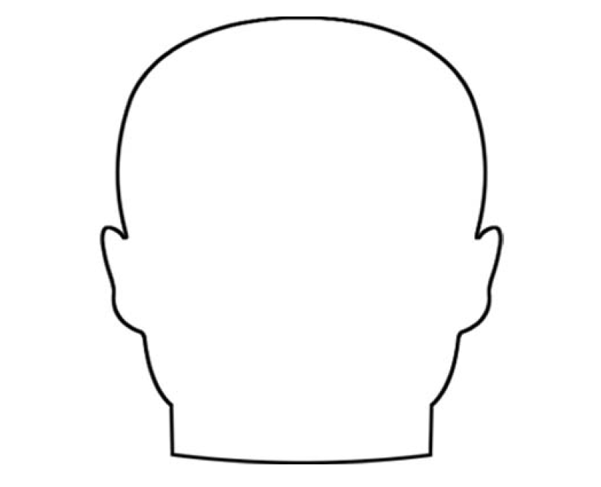

Freeology.com

Reading Activities: Chapters 13 and 14

Discussion/Journaling Questions:
(Individual or Group Activity)

- Why do you think Kenny insists on going to Collier’s Landing?
- Why does Bryon cry over Kenny? What does this tell you about By?
- Why does Joey think that Kenny has changed his clothes?
- How do the events in Chapter 14 make you feel? Why?
http://www.planetbookclub.com/kids/archive/watsons2.00/watsonsintro.html

The Birmingham Church Bombing: KWL Activity
(Individual Activity)

What do you know about the civil rights movement? What would you like to know? Complete the first two columns of the KWL chart.
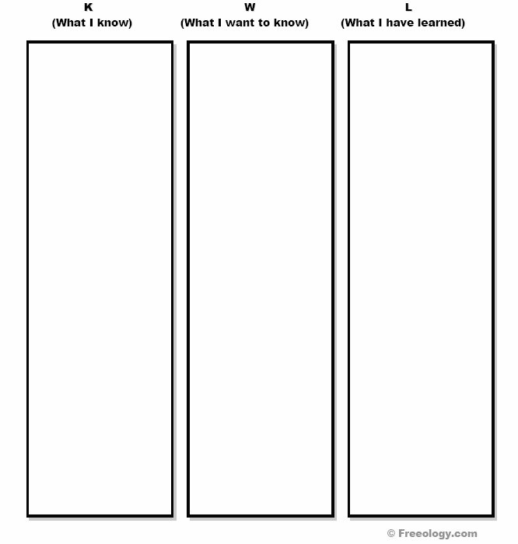

Internet Workshop: The Birmingham Church Bombing
(Individual Activity)

DIRECTIONS: Now we will complete the KWL chart. Use a search engine to identify reputable websites to find answers to your questions about the Birmingham Church Bombing. The following sites may be useful in starting your search.

Dudley Randall’s “Ballad of Birmingham” http://webinstituteforteachers.org/~vfjohnson/ballbham.html

In Memory of Four Little Girls
http://www.useekufind.com/peace/

Historic Places of the Civil Rights Movement
http://www.cr.nps.gov/nr/travel/civilrights/

History Learning Site
http://www.historylearningsite.co.uk/birmingham.htm

Alabama Department of History
http://www.archives.state.al.us/teacher/rights/rights3.html

After you have completed the KWL chart, assume the role of reporter for a local newspaper. Using the information you have learned during the Internet Workshop write a press release describing the Birmingham church bombing and the events leading up to it. Be prepared to share with the class. This activity is worth 6 points.

 | 1 | 2 | 3
Subject Matter | Student presents information that is inaccurate or lacks details. | Student presents information that is accurate, but offers only limited details. | Student presents information that is accurate and offers numerous details.
Grammar | Student writing has more than three grammatical errors | Student writing has one or two grammatical errors. | Student writing is free of grammatical errors.
Spelling | Student writing contains more than three misspelled words. | Student writing contains one or two misspelled words. | Student writing is free of misspelled words.

The Morganton NewsHerald | 12345 Main Street  Morganton, NC 28655  Phone (828) 555-0190  Fax (828) 555-0191
Press Release
Contact: ________________________  Phone: (828) 555-0190 | FOR IMMEDIATE RELEASE

-End-

Human Rights Activity

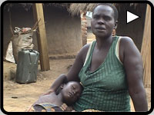

Nearly two million people are internally displaced in Northern Uganda, a region in conflict for the last two decades. http://www.witness.org/



Millions of women throughout the world live in conditions of abject deprivation of, and attacks against, their fundamental human rights for no other reason than that they are women. http://www.hrw.org/women/

Excerpts from the Universal Declaration of Human Rights
http://www.un.org/Overview/rights.html

On December 10, 1948 the General Assembly of the United Nations adopted and proclaimed the Universal Declaration of Human Rights the full text of which appears in the following pages. Following this historic act the Assembly called upon all Member countries to publicize the text of the Declaration and "to cause it to be disseminated, displayed, read and expounded principally in schools and other educational institutions, without distinction based on the political status of countries or territories."

Article 1.
All human beings are born free and equal in dignity and rights.They are endowed with reason and conscience and should act towards one another in a spirit of brotherhood.

Article 2.
Everyone is entitled to all the rights and freedoms set forth in this Declaration, without distinction of any kind, such as race, colour, sex, language, religion, political or other opinion, national or social origin, property, birth or other status. Furthermore, no distinction shall be made on the basis of the political, jurisdictional or international status of the country or territory to which a person belongs, whether it be independent, trust, non-self-governing or under any other limitation of sovereignty.

Article 3.
Everyone has the right to life, liberty and security of person.

Article 4.
No one shall be held in slavery or servitude; slavery and the slave trade shall be prohibited in all their forms.
Article 5.
No one shall be subjected to torture or to cruel, inhuman or degrading treatment or punishment.

Article 6.
Everyone has the right to recognition everywhere as a person before the law.

Article 7.
All are equal before the law and are entitled without any discrimination to equal protection of the law. All are entitled to equal protection against any discrimination in violation of this Declaration and against any incitement to such discrimination.

Article 8.
Everyone has the right to an effective remedy by the competent national tribunals for acts violating the fundamental rights granted him by the constitution or by law.

Article 9.
No one shall be subjected to arbitrary arrest, detention or exile.

Article 10.
Everyone is entitled in full equality to a fair and public hearing by an independent and impartial tribunal, in the determination of his rights and obligations and of any criminal charge against him.

Article 11.
(1) Everyone charged with a penal offence has the right to be presumed innocent until proved guilty according to law in a public trial at which he has had all the guarantees necessary for his defence.
(2) No one shall be held guilty of any penal offence on account of any act or omission which did not constitute a penal offence, under national or international law, at the time when it was committed. Nor shall a heavier penalty be imposed than the one that was applicable at the time the penal offence was committed.

Article 12.
No one shall be subjected to arbitrary interference with his privacy, family, home or correspondence, nor to attacks upon his honour and reputation. Everyone has the right to the protection of the law against such interference or attacks.

Article 13.
(1) Everyone has the right to freedom of movement and residence within the borders of each state.
(2) Everyone has the right to leave any country, including his own, and to return to his country.

Article 14.
(1) Everyone has the right to seek and to enjoy in other countries asylum from persecution.
(2) This right may not be invoked in the case of prosecutions genuinely arising from non-political crimes or from acts contrary to the purposes and principles of the United Nations.

Article 15.
(1) Everyone has the right to a nationality.
(2) No one shall be arbitrarily deprived of his nationality nor denied the right to change his nationality.

Article 16.
(1) Men and women of full age, without any limitation due to race, nationality or religion, have the right to marry and to found a family. They are entitled to equal rights as to marriage, during marriage and at its dissolution.
(2) Marriage shall be entered into only with the free and full consent of the intending spouses.
(3) The family is the natural and fundamental group unit of society and is entitled to protection by society and the State.

Article 17.
(1) Everyone has the right to own property alone as well as in association with others.
(2) No one shall be arbitrarily deprived of his property.

Article 18.
Everyone has the right to freedom of thought, conscience and religion; this right includes freedom to change his religion or belief, and freedom, either alone or in community with others and in public or private, to manifest his religion or belief in teaching, practice, worship and observance.

Article 19.
Everyone has the right to freedom of opinion and expression; this right includes freedom to hold opinions without interference and to seek, receive and impart information and ideas through any media and regardless of frontiers.

Article 20.
(1) Everyone has the right to freedom of peaceful assembly and association.
(2) No one may be compelled to belong to an association.

Article 21.
(1) Everyone has the right to take part in the government of his country, directly or through freely chosen representatives.
(2) Everyone has the right of equal access to public service in his country.
(3) The will of the people shall be the basis of the authority of government; this will shall be expressed in periodic and genuine elections which shall be by universal and equal suffrage and shall be held by secret vote or by equivalent free voting procedures.

Article 22.
Everyone, as a member of society, has the right to social security and is entitled to realization, through national effort and international co-operation and in accordance with the organization and resources of each State, of the economic, social and cultural rights indispensable for his dignity and the free development of his personality.

Article 23.
(1) Everyone has the right to work, to free choice of employment, to just and favourable conditions of work and to protection against unemployment.
(2) Everyone, without any discrimination, has the right to equal pay for equal work.
(3) Everyone who works has the right to just and favourable remuneration ensuring for himself and his family an existence worthy of human dignity, and supplemented, if necessary, by other means of social protection.
(4) Everyone has the right to form and to join trade unions for the protection of his interests.

Article 24.
Everyone has the right to rest and leisure, including reasonable limitation of working hours and periodic holidays with pay.

Article 25.
(1) Everyone has the right to a standard of living adequate for the health and well-being of himself and of his family, including food, clothing, housing and medical care and necessary social services, and the right to security in the event of unemployment, sickness, disability, widowhood, old age or other lack of livelihood in circumstances beyond his control.
(2) Motherhood and childhood are entitled to special care and assistance. All children, whether born in or out of wedlock, shall enjoy the same social protection.

Article 26.
(1) Everyone has the right to education. Education shall be free, at least in the elementary and fundamental stages. Elementary education shall be compulsory. Technical and professional education shall be made generally available and higher education shall be equally accessible to all on the basis of merit.
(2) Education shall be directed to the full development of the human personality and to the strengthening of respect for human rights and fundamental freedoms. It shall promote understanding, tolerance and friendship among all nations, racial or religious groups, and shall further the activities of the United Nations for the maintenance of peace.
(3) Parents have a prior right to choose the kind of education that shall be given to their children.

Article 27.
(1) Everyone has the right freely to participate in the cultural life of the community, to enjoy the arts and to share in scientific advancement and its benefits.
(2) Everyone has the right to the protection of the moral and material interests resulting from any scientific, literary or artistic production of which he is the author.

Article 28.
Everyone is entitled to a social and international order in which the rights and freedoms set forth in this Declaration can be fully realized.

Article 29.
(1) Everyone has duties to the community in which alone the free and full development of his personality is possible.
(2) In the exercise of his rights and freedoms, everyone shall be subject only to such limitations as are determined by law solely for the purpose of securing due recognition and respect for the rights and freedoms of others and of meeting the just requirements of morality, public order and the general welfare in a democratic society.
(3) These rights and freedoms may in no case be exercised contrary to the purposes and principles of the United Nations.

Article 30.
Nothing in this Declaration may be interpreted as implying for any State, group or person any right to engage in any activity or to perform any act aimed at the destruction of any of the rights and freedoms set forth herein.

Bill of Rights
(http://usinfo.state.gov/usa/infousa/facts/funddocs/billeng.htm)

Amendment I: Congress shall make no law respecting an establishment of religion, or prohibiting the free exercise thereof; or abridging the freedom of speech, or of the press; or the right of the people peaceably to assemble, and to petition the government for a redress of grievances.

Amendment II: A well regulated militia, being necessary to the security of a free state, the right of the people to keep and bear arms, shall not be infringed.

Amendment III: No soldier shall, in time of peace be quartered in any house, without the consent of the owner, nor in time of war, but in a manner to be prescribed by law.

Amendment IV: The right of the people to be secure in their persons, houses, papers, and effects, against unreasonable searches and seizures, shall not be violated, and no warrants shall issue, but upon probable cause, supported by oath or affirmation, and particularly describing the place to be searched, and the persons or things to be seized.

Amendment V: No person shall be held to answer for a capital, or otherwise infamous crime, unless on a presentment or indictment of a grand jury, except in cases arising in the land or naval forces, or in the militia, when in actual service in time of war or public danger; nor shall any person be subject for the same offense to be twice put in jeopardy of life or limb; nor shall be compelled in any criminal case to be a witness against himself, nor be deprived of life, liberty, or property, without due process of law; nor shall private property be taken for public use, without just compensation.

Amendment VI: In all criminal prosecutions, the accused shall enjoy the right to a speedy and public trial, by an impartial jury of the state and district wherein the crime shall have been committed, which district shall have been previously ascertained by law, and to be informed of the nature and cause of the accusation; to be confronted with the witnesses against him; to have compulsory process for obtaining witnesses in his favor, and to have the assistance of counsel for his defense.

Amendment VII: In suits at common law, where the value in controversy shall exceed twenty dollars, the right of trial by jury shall be preserved, and no fact tried by a jury, shall be otherwise reexamined in any court of the United States, than according to the rules of the common law.

Amendment VIII: Excessive bail shall not be required, nor excessive fines imposed, nor cruel and unusual punishments inflicted.

Amendment IX: The enumeration in the Constitution, of certain rights, shall not be construed to deny or disparage others retained by the people.

Amendment X: The powers not delegated to the United States by the Constitution, nor prohibited by it to the states, are reserved to the states respectively, or to the people.

Writing Activity: Universal Declaration of Human Rights Vs. Bill of Rights

DIRECTIONS: After reading the United Nation’s Universal Declaration of Human Rights and the United States’ Bill of Rights, write a summary highlighting major similarities and differences between the two documents. This activity is worth a total of 12 points.

 | 1 (Weak) | 2 (Acceptable) | 3 (Superior)
Thesis states topics and main idea. | Thesis does not state topics and main idea. | Thesis partially states topics and main idea. | Thesis clearly states topics and main idea.
Supporting details discussed are factually correct and support the main idea. | Supporting details are not present, are factually inaccurate, or do not support the main idea. | Supporting details discussed are factually correct and somewhat support the main idea. | Supporting details discussed are factually correct and support the main idea.
Specific examples are given to support the main idea. | Specific examples are absent. | Specific examples are given but they fail to support the main idea. | Specific examples are accurately given to support the main idea.
Grammar | More than 5 grammatical errors. | 3-5 grammatical errors. | 1 or 2 grammatical errors.

Current Events Writing Activity: Human Rights Watch
(Individual and Small Group Activity)

DIRECTIONS: Research a current human rights issue. Take detailed notes on the information you find and be prepared to share your findings in small groups.

Human Rights Watch http://www.hrw.org/

Witness http://www.witness.org/

Amnesty International http://www.amnesty.org/

Reading Activities: Chapter 15 and Epilogue

Discussion/Journaling Questions:
(Individual or Group Activity)

- Has Kenny changed at the end of the story? If so, how?
- Has Bryon changed? If so, how?
- Why does talking to Bryon make Kenny feel better?
- What kinds of magic powers does Kenny believe in?
- Why do you think Christopher Paul Curtis wrote this book?
http://www.planetbookclub.com/kids/archive/watsons2.00/watsonsintro.html

Interview the Watsons
(Small Group Activity)
In this role-play activity, students will be grouped into groups of three. One student will assume the role of interviewer and two students will assume character roles of their choice from the novel. The group will generate a set of questions for each character. There should be no less than 5 questions per character. Each group will demonstrate their skit (interview) for the class. You will be assessed based on the following rubric. This activity is worth 25 points.

 | Possible Points | Self-Assessment | Teacher Assessment
Presentation was well planned and coherent. | 5
Explanations and details provided. | 5
Communication aids were clear and useful. | 5
Each character responded to five questions. | 5
Displayed appropriate body language and speech skills. | 5

Rate each category according to the following scale: 9-10 = excellent, 7-8 = very good, 5-6 = good, 3-4 = satisfactory, 1-2 = poor, and 0 = unsatisfactory.

Post-Reading Activity: Extension Project
(Group Project)

DIRECTIONS: For this activity students will work in groups of 4 or 5. The group will be responsible for deciding who will be responsible for each of the following roles. All members of the groups will be assigned the job of Artist. One person will be the Travel Guide, there will be a Biographer, a Chronologist/Time Line creator, and one or two Newspaper Reporters. All members of the group will also be assigned the job of Artist. Each group will present their project to the class. This activity is worth 100 points. http://www.tesd.k12.pa.us/tems/library/Watson's.htm

Travel Guide

An important aspect of any family trip notebook is detailed information about the trip itself. As the travel guide, you will gather and formulate information about how long the trip will take, the distance from Birmingham to Flint, and information about the trip in general. This will help us look back at exactly what we did and what we could do if we were to take the trip again. Your job as the Travel Guide is to gather the following information:

- What is the best route they can take? Include a map with the highlighted route.
- What states will they travel through? List them in the order the family will follow on the trip to Birmingham.
- Design a fact sheet about the trip that includes:
- How many miles is the trip?
- If the Brown Bomber can travel at approximately 55 mph, how many hours will the trip take?
- Mr. Watson said he wanted to drive for 5 or 6 hours a day, how many days should the trip take?
- What are some of the tourist attractions or historical sights along the way?

Create three original postcards from places that the family might have visited on their trip. (Be sure the site existed in 1963)

Newspaper Reporter

What might newspaper articles say about what happened in Birmingham in 1963? Can you help create articles? The articles should be written in the basic newspaper form and each Reporter will create at least two articles. When possible, use eyewitness accounts from web pages and include the following criteria in each article:

- The answers to the basic journalism questions, who, what, where, why, when and how.
- An effective lead sentence and headline that will draw the reader's attention.
- The name of a newspaper the Watson's might have read in 1963.
- Your page should look like a page from a real newspaper. The articles should be typed in a two-column format.
- Include pictures for each article.
- I need articles about the bombing at the church, the boycotts, and riots, I also need information about the four girls who were killed. Please include pictures of the girls with the article.

Try these sites:
The "Four Little Girls" Movie Website
http://www.4littlegirls.com/
Washington Post Newspaper Article
http://www.washingtonpost.com/wp-srv/national/longterm/churches/archives1.htm
The16th Street Baptist Church Bombing http://afroamhistory.about.com/library/weekly/aa051401a.htm

Chronologist/Timeline Creator

For African-Americans, life in 1963 was quite different from life today, especially in the South. The 60's were very turbulent, but led to many positive changes for all Americans. When my children get a bit older, they will need to understand the events that lead to the bombing and events that followed it. To understand this, I need you to gather information about the events in the South from 1950 to 1965 and then create a timeline for the scrapbook.

The timeline needs:

- Timeline span is 1950-1965
- Events must have happened between these years.
- Include at least 2 pictures of events or important people
- Each event should be described with at least two sentences
- Include 6 or more events

Your events may include:

- Brown vs. Board of Education
- Bus Boycott in Montgomery, Alabama
- Freedom Rides
- March on Washington - 1963

Try these sites:
The Martin Luther King Home Page
http://seattletimes.nwsource.com/mlk/index.html
National Civil Rights Museum
http://www.civilrightsmuseum.org/gallery/movement.asp
Western Michigan University's Timeline of the American Civil Rights Movement http://www.wmich.edu/politics/mlk/
The "Four Little Girls" Movie site
http://www.4littlegirls.com/
The "Powerful Days in Black and White" Photo Exhibit http://www.kodak.com/US/en/corp/features/moore/mooreIndex.shtml

Biographer

It will also be essential for my children to understand about the people who were important to the Civil Rights Movement in the 1950s and 60s. The Biographer's job will be to tell the children about the important leaders of the time. As a Biographer, you will research and report on two people who were well known between 1950 and 1965. Each of the two reports needs to:

- Identify the person
- Describe what this person did
- Explain the importance of the person's contribution to the Civil Rights Movement
- Include the person's picture
- Each biography should be at least 1 1/2 pages long.

Artist

Every good travel scrapbook needs pictures! Each group member needs to contribute at least two illustrations to show our family's trip to Birmingham. The pictures can be from the internet or any other source. If you wish, you may draw pictures showing events from the novel. Your pictures need to match the part of the scrapbook that you make and should not duplicate those of any other group member.

- Two illustrations from each person
- Your pictures need to match your part of the scrapbook
- Pictures should not duplicate those of any other group member
- A caption is needed for each picture or drawing
- Name of the artist on the back of the picture
- A list of the illustrations will be included in the scrapbook.

Extension Project Rubric

CATEGORY | 4 (100-90) | 3 (89-80) | 2 (79-70) | 1 (69-60)
Knowledge of Material | Project clearly communicates knowledge of book, characters, main ideas, and themes | Project adequately communicates knowledge of book, characters, main ideas, and themes | Project partially communicates knowledge of book, characters, main ideas, and themes | Project communicates little or no knowledge of book, characters, main ideas, and themes
Historical Content | Project presents detailed historical and geographical information | Project presents an adequate account of historical and geographical information | Project presents some historical and geographical information | Project presents no historical and geographical information
Creativity | Product shows a large amount of original thought. Ideas are creative and inventive. | Product shows some original thought. Work shows new ideas and insights. | Uses other people's ideas (giving them credit), but there is little evidence of original thinking. | Uses other people's ideas, but does not give them credit.
Sources | Source information collected for all graphics, facts and quotes. All documented in desired format. | Source information collected for all graphics, facts and quotes. Most documented in desired format. | Source information collected for graphics, facts and quotes, but not documented in desired format. | Very little or no source information was collected.
Mechanics | No misspellings or grammatical errors. | Three or fewer misspellings and/or mechanical errors. | Four misspellings and/or grammatical errors. | More than 4 errors in spelling or grammar.
Workload | The workload is divided and shared equally by all team members. | The workload is divided and shared fairly by all team members, though workloads may vary from person to person. | The workload was divided, but one person in the group is viewed as not doing his/her fair share of the work. | The workload was not divided OR several people in the group are viewed as not doing their fair share of the work.
Technology | Technology used correctly (see specific lists for internet, video camera, tape recorder, word processor, etc) | Most aspects of technology used correctly | Need further instruction in use of technology | Technology used incorrectly. Inappropriate use or damage to equipment resulted.

http://rubistar.4teachers.org/index.php?screen=ShowRubric&rubric_id=1227250&

Final Multi-Text Study Assessment

PART I: TRUE OR FALSE

DIRECTIONS: Mark each question by writing “true” or “false” at the end of each sentence. Write the whole word out. Do not mark “t” or “f” as you will not receive credit for these responses. Each correct response is worth 1 point (total 5 points).

- The civil rights movement began after the Birmingham church bombing.

- The NAACP was formed in 1909.

- One of Kenny’s nicknames was Poindexter.

- Joey Watson acted as the mediator between Momma and Bryon.

- The Greensboro Sit-Ins occurred before the Montgomery Bus Boycott.

PART II: FILL-IN-THE-BLANK

DIRECTIONS: Correctly complete the following sentences. Each correct response is worth 1 point (total 5 points).

- The Greensboro Sit-Ins occurred at a ________________________________.

- Bryon and his Flamethrower of Death battled the ___________________.

- The Watsons lived in __________________, _______________________ (city and state).

- _____________________________ is a present-day human rights issue.

- The civil rights movement was launched in __________________.

PART III: SHORT ANSWER

DIRECTIONS: Answer two of the following three short answer questions. Each response is worth 20 points (total 40 points).

- Christopher Paul Curtis uses many literary devices in The Watsons Go to Birmingham. Choose one literary device and describe how it is used in the novel.

- Choose one of the characters from The Watsons Go to Birmingham and explain how he or she changed throughout the novel.

- Explain what affect the Greensboro Sit-Ins had on the civil rights movement.

PART IV: ORDER

DIRECTIONS: Correctly list the following events in chronological order from earliest to most recent (5 is the most recent and 1 is the earliest). The order will be considered entirely correct or entirely incorrect. There are 2 order problems. Each correct order is worth 5 points (10 points total).

________ Bryon’s tongue freezes to the mirror.

________ Kenny makes a new friend, Rufus.

________ The Watson children meet Grandma Sands.

________ Kenny and Joey worry about the “froze-up Southern folks.”

________ First Street Baptist Church in Birmingham is bombed.

________ The NAACP is founded in New York.

________ Rosa Parks and the Montgomery Bus Boycott

________ President Kennedy is assassinated.

________ The Sit-Ins take place in Greensboro, North Carolina.

________ “Letter from a Birmingham Jail” by Martin Luther King, Jr.

Part V: Vocabulary

DIRECTIONS: For each of the following vocabulary words, define the word and correctly use the word in a sentence. Each correct definition is worth 1.5 points and each correct sentence is worth 1.5 points (total 40 points).

Boycott
Civil Rights Movement

Resistance

Hero

Martin Luther King, Jr.

Rosa Parks

Ultra-Glide

NAACP

Equality

First Street Baptist Church

Protest

Prejudice

African American

Additional Reading Selections

Below is a suggested reading list of books that share common themes with The Watsons Go to Birmingham-1963 and/or Freedom on the Menu: The Greensboro Sit-Ins. I have purposefully included a variety of books that include poetry, fiction, and nonfiction so that everyone has the opportunity to select a genre that they find appealing. I chose The Watsons Go to Birmingham for us to read as a class because it is a good example of historical fiction. Nevertheless, it is important for you to have freedom in choosing what you read based on your personal taste. No matter which book you chose to read from the following list (and I hope you will read more than one, if not all of them) you will expand your knowledge, awareness, and understanding of African American heritage, the civil rights movement, and the complexity of human nature.

- The Palm of My Heart: Poetry by African American Children is a collaborative work of young writers between eight and fourteen years old that celebrates African American heritage.

- M. C. Higgins, the Great by Virginia Hamilton is about a young boy trying to keep his family together and safe from impending disaster. Similar to Kenny Watson, this boy is confronted with adult situations and grown-up responsibilities.

- In Daddy's Arms I Am Tall: African Americans Celebrating Fathers is a collection of twelve short poems that illustrate the fantastic bond between father and child, much like the special bond that Kenny and his father share.

- Now Is Your Time! the African American Struggle for Freedom by Walter D. Myers is a narrative of African American history with biographies that salute leaders of the civil rights movement.

- Journey to Jo'Burg by Beverley Naidoo is a story of a boy and girl’s realization of the hardships brought about by the apartheid as they search for their mother. Like the Watson children, this boy and girl lose their innocence as they recognize the effects society plays on their lives.

- Bridge to Terabithia by Katherine Paterson is a story of an enduring friendship, a tragic accident, and confronting loss and grief. Like the Watsons, this book celebrates the joy of friendship on one level and the pain of grief on the other end of the spectrum.

- Maniac Magee by Jerry Spinelli is about how one boy confronts racism in his neighborhood.

- Roll of Thunder, Hear My Cry by Mildred D. Taylor tells the story of an African American family trying to overcome racism and prejudice in the south during the 1930’s. This book illustrates the similarities and differences in the south thirty years prior to the Watson’s trip to Birmingham.

- The Friendship by Mildred D. Taylor is about the complexity of friendship and the racism and prejudice that existed in the south in the 1930’s. Like The Watsons Go to Birmingham and Freedom on the Menu, this book illustrates the complexity and effects of racism.



Adedjouma, Davida, ed. The Palm of My Heart: Poetry by African American Children. New York: Lee & Low Books, 1996.

Hamilton, Virginia. M.C. Higgins, the Great. New York: Collier, 1974.

In Daddy's Arms I Am Tall: African Americans Celebrating Fathers. New York: Lee & Low Books, 1987.

Myers, Walter D. Now Is Your Time! the African American Struggle for Freedom. New York: Scholastic Inc., 1993.

Naidoo, Beverley. Journey to Jo'Burg. New York: J.B. Lippincott, 1985.

Paterson, Katherine. Bridge to Terabithia. New York: Crowell, 1977.

Spinelli, Jerry. Maniac Magee. New York: Harpertrophy, 1990.

Taylor, Mildred D. Roll of Thunder, Hear My Cry. New York: Phyllis Fogelman Books, 2001.

Taylor, Mildred D. The Friendship. New York: Dial Books for Young Readers, 1987.

After-Reading Survey
(Individual Activity)

I would like to how what you thought about The Watsons go to Birmingham. Would you recommend it for future classes? Do you have any suggestions for improvement on the activities in this packet? Please complete this brief survey at the end of our novel study and put it in my box. You do not have to put your name on this page.

- Did you enjoy reading The Watsons go to Birmingham – 1963 by Christopher Paul Curtis? Why or why not?

- Which activities in this packet did you enjoy most? Which were the most educational? Why?

- Which activities in this packet did you enjoy the least? Which did you find the least educational? Why?

- Do you have any suggestions for future activities?

- Did you enjoy reading Freedom on the Menu: The Greensboro Sit-Ins by Carole Boston Weatherford? Why or why not?

