**5710 Comprehensive Exam**

**Classroom Context**

My classroom sits in a rural setting. The school is known by most in the community as the “heart.” It is an everyday occurrence to see police officers, firefighters and local business owners walking the halls of our school as part of our Watch Dog Program. They are a huge support for our staff and students. The school is small with just over 400 students attending. We are lucky to have a fair amount of ethnic diversity although Caucasian students make up the majority of the population. Hmong, Hispanic, and Hearing Impaired student also sit in our classrooms along with a large number of students who are labeled as Exceptional Children (EC) or students served by 504 accommodations due to other medical diagnosis.

Sixth Grade is unique to the rest of the school because students are grouped based on data collected from last year’s End of Grade Test (EOG) scores and classroom performance. Students are clustered into three groups. My first Language Arts block encompasses twenty students who have either failed, scored a level one or two, on their fifth grade Math or Reading EOG or were with a couple of points from failing. My second Language Arts block contains three groups of students. Eight Students have been labeled as Academically or Intellectually Gifted (AIG), six students are served by the English as a Second Language (ELS) program, while the remaining thirteen are students who scored a level four or were within points of this score on last year’s EOG in the areas of math or reading. My last block of twenty-two students contains a rage of students who either passed the EOG within a couple of points or scored a solid three on the EOG.

**Assessment**

Informal Reading Inventory

I realize that the most important assessment I need to implement in my classroom will assist me in finding text that are at the appropriate level of challenge for all of my students. The best way to find out what level a child is reading on is to administer an Informal Reading Inventory (IRI) which includes assessing children’ ability to recognize words in context and in isolation.

Reading materials must be at the appropriate level of challenge in order for my students to benefit from reading. If one of my sixth graders who is reading on a fourth grade level only reads text at a sixth grade level, they will not make growth during the school year. When children are reading by themselves, they should read books at their independent reading level which is a text they can read with 98% accuracy and quick speed. When students are working with me; they should be able to read 95% of the words accurately with speed and at least 70% comprehension. This is their instructional reading level. Perfettti/ Hogaboam (1975) found poor readers spend too much energy decoding the text. When reading text with many words more than 95% not already stored in your lexicon, reading becomes frustrating and too much energy is spent trying to figure out the words rather than making meaning of the text.

Understanding children need to read on their independent and instructional levels means that I cannot assess students based on their performance on grade level reading materials in isolation (EOGs). Rather, the knowledge of how to properly and accurately administer an Informal Reading Inventory which includes assessing student’s knowledge of spelling patterns with a spelling inventory, their word recognition in isolation, their reading rate and word recognition in context along with their comprehension is a valuable skill to have. In addition, I also need to assess my students listening comprehension by reading a text aloud and having the child answer questions about the text. By administering an IRI to all of my students, I can place them into texts that will help them to grow and develop as a reader.

Student Interest Inventories

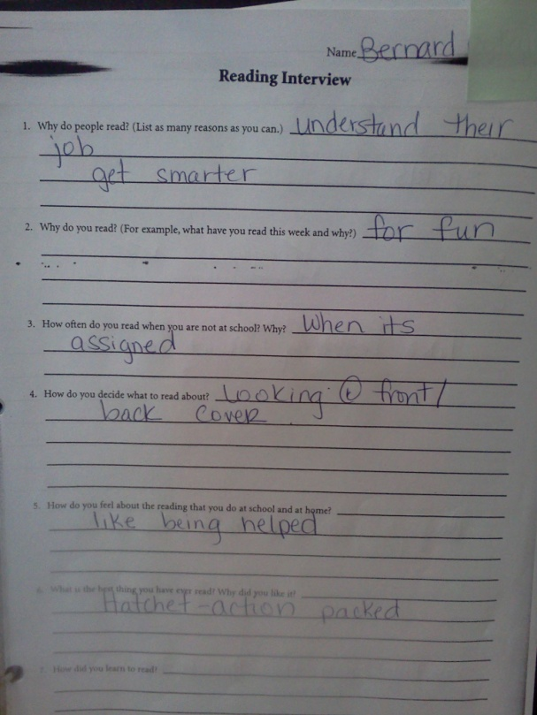I conducted reading interviews during the first month of the school year. From these assessments and through our conversation, I was able to get a glimpse into the reading habits, attitudes and interest of my students. Through, conducing this type of assessment a teacher learns valuable information about what the classroom library needs to include in order to motivate students to read.

**Reading Instruction**

When thinking about the best way to teach my sixth graders, I base my practice on the premises that the only way to improve in reading is by reading. I know this sounds obvious. However, the practice of reading is instrumental to learning to read due to the fact that the more exposure a child has to print the more generalizations they will be able to make about the way letters break into sounds which make words that combine into sentences. Children will develop automatic word recognition as they encounter the same words across multiple texts and begin to make meaning from the text as more mental energy shifts from letters and sounds to understanding what the words are saying.

Adams (2004) study found that reading is not top down or bottom up but is instead is a complex process which involves multiple processors working together. Some people may believe that all that is needed in order for a child to learn to read is a strong foundation in phonics or the way letters sound. But, if children simply learn to read by breaking down words without learning to read in context they will not develop a lexicon of words which is necessary for automatic word recognition.

Which means the bulk of my language arts time needs to be spent practicing reading. Within, my eighty minute language arts block, 40% of time should be spent reading. In my class, this looks like a ten minute mini-lesson in which I model reading from a variety of genres and model how I use strategies to comprehend what I read. However, I feel like students simply practicing how to read through reading texts at the appropriate level of challenge is really how we learn to make meaning from the text we read, not through the explicit teaching of comprehension strategies.

**Poetry**

In order to meet my students fluency needs, I am using a weekly poetry study routine to promote fluency (I call it Poem of the Week) which takes about seven minutes per day. Repeated readings of a text are a research based method and is considered a best practice for increasing fluency. Jay Samuel’s (1979) research found when students orally practiced a piece of text their rate, accuracy and comprehension of that text improved. Since poetry is meant to be read aloud, I feel it is a natural choice for repeated reading for my sixth graders. I choose a poem that goes along with a thematic unit of study such as The Civil Rights Movement or the Holocaust for my students to read all week. By exposing students to a variety of poems with the same theme, I hope to increase student’s vocabulary since we often encounter many of the same words in the various poems. During the week, I will model reading the text, students will echo read, we will read chorally and students will read with partners. By the end of the week, students have read the poem at least five times and are required to respond through writing to the poem so that I can assess their comprehension of the piece.

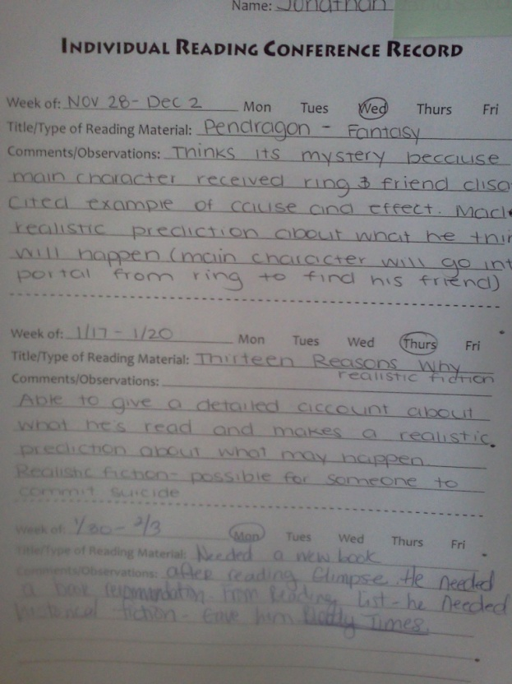**Independent Reading**

Heavy emphasis is place on independent reading in my sixth grade classroom. I understand my students need about an hour-and-a-half practice reading on their independent and instructional reading levels each day. Since students only spend about thirty minutes reading within the language arts block, they need to spend additional time outside of the classroom engaged in reading texts of their choice. Since reading at home competes with many other activities such as playing sports, video games, spending time on the computer and texting. It is critical that I help students find text they want to read. I was forced to ask myself some questions about my own reading habits after examining several opinions about whether teachers need to have a love for literacy in order to be effective (Powell-Brown, 2003). In addition to reading the 2009 research of Mckool and Gespass who decided to investigate the effect of teacher’s personal passion for reading and the implications this has on their classroom literacy practices. These researchers found that teachers with self-proclaimed passions for reading were more likely to use best practices for literacy instruction more often than teachers who spent little time reading. After reflecting on these, it is my opinion that teachers need to spend time reading text their students read, so books can be shared with students. Fortunately, I do have a passion and fall into the category of being a very committed reader. Because of this, I am able to motivate many students in my classroom to spend time reading by suggesting books to them, reading the most exciting parts of books aloud, conferencing with students about their reading and by allowing time in class for students to talk about books.

**Spelling and Word Study**

I assess my student’s knowledge of how letters work in words with a spelling with the Schlagal Spelling Inventory. I analyze these to find the highest grade level which the student scored at least 50% correct and then evaluate spellings and misspellings on this test to find out what the child does and does not know.

Due to limited time and lack of time for planning, I am not currently implementing word sort lessons the way I know is most beneficial. In the future, I plan to develop word sort lessons for students at their instructional spelling level which will focus on strengthening the patterns they know and teaching them the patterns they do not. Right now, I teach spelling by asking my students to do easy reading which allows the orthographic processor to work with the meaning processor and allow students to pay attention to the meaning of the text therefore helping students develop a tacit knowledge of spelling patterns.

Writing for genuine purpose without fear of error also helps my sixth graders learn how letters work in words because they are allowed to experiment with words and are able to use their knowledge about letter sounds which will help them to make growth in spelling.

**Writing**

My sixth graders learn to value their writer’s notebooks and often ask when they will be able to work on their writing. I allow my students to write about topics which interest them and stay away from giving whole-class writing prompts. It is hard to get quality writing from my students when they do not have a choice about what to write about.

Instead, I have my students listen to and read mentor text from within the genre I want them to write. My sixth graders read and write memoirs, letters to the editor, informational texts and traditional literature. We study the author’s craft with a mini-lesson about what the author does well and then I allow my students time to practice the craft followed by time to share their writing. I feel it is important for my students to discuss their writing throughout the writing process with the whole group, in small groups, partners and conferences with me. I ask my students to write many drafts in their writer’s notebooks with the knowledge they will only bring one piece per nine weeks through the entire writing process. I teach the writing process as talking about our ideas for writing, pre-writing, drafting, revising for clarity, editing and preparing a final copy. I conduct mini-lessons during all stages of the writing process. I evaluate my students with rubrics and do not get caught up with spelling errors. This is a small portion of my student’s evaluation.

**Meeting the needs of all of my Students**

Surprisingly enough, meeting the needs of the variety of students in my classroom each day involves a very similar routine. My method for teaching does not change. However, the difficulty level of text and assigned task is modified based on the differing readiness levels of my students. Meeting with small groups of students with similar reading levels enables me to better meet the unique needs of my students. One very important difference between my highest leveled readers (those reading at least two grade levels above sixth grade) and those reading two or more grade levels below is their motivation to read. Perhaps, due to their lack of success contributing to the Mathew Effect as coined by Keith Stanovich (1986) to explain why some struggling readers dislike reading and therefore spend very little time practicing the skill.

I understand the need to experience success with a text. As a reader myself, I appreciate the emotional engagement that happens as comprehension is developed. The “I can’t put the book down because I have to know what is going to happen next” feeling is not one many kids in my lowest reading group and I share. Researchers, Wolfe and Barzillai (2009) explain this type of engagement with a text to be called deep reading. Understanding how reading develops helps to explain why I never see some of my students experience the euphoria of a good book.

Knowing, reading is a parallel process that evokes many processors to work together. The orthographic, semantic, syntactic and phonological processors enable a reader to recognize and understand words which enable fluency which in turn allows readers time to think and comprehend (Wolfe & Stoodley, 2007). This time to think is a gift many of the struggling readers in my class have yet to receive and help to explain why they fail to get the gist of a story and often do poorly on comprehension tasks.

Unfortunately, my endless book recommendations, engaging lessons, constant push for comprehension monitoring through strategy instruction and “you can do it pep-talks” are not enough. They need explicit instruction on their instructional and independent levels to move from basic decoding to fluent reading in order to grow as readers. I want to help these students begin to make meaning from the text and model use of strategies I use to understand what I read in addition to providing time for students to practice and discuss. I know the only way for this to happen is spending a lot of time reading from a variety of text.

While my higher level readers also need practice on their instructional reading level, these students often spend more time outside of class reading books of their choice. My focus with these students is to extend their thinking outside of their text into other text as well as inside the context of our world. Often this is achieved through independent research projects and participation in book club discussions. But, ultimately, my biggest job is to ensure they keep up their reading stamina.

**References**

McKool, ., & Gespass, S. (2009). Does johnny’s reading teacher love to read? how teachers’ personal reading habits affect instructional practices. *Literacy Research and Instruction, 48,* 264-276.

Perfetti, C. and Hogaboam, T. (1975). Relationship between Single word decoding and reading comprehension skill. *Journal of Educational Psychology, 67, 4*, 461-469.

Powell-Brown, A. (2003). Can you be a teacher of literacy if you don’t love to read? *Journal of Adolescent & Adult Literacy, 47(4)*, 284-288.

Samuels, S.J. (1979). The method of repeated readings. [*The Reading Teacher,*](http://www.reading.org/publications/rt/) *21,* 360-407.

Stanovich, K.E. (1986). Matthew effects in reading: Some consequences of individual differences in the acquisition of literacy. Reading Research Quarterly, 21(4), 360–407.

Wolfe, M., & Barzillai , M. (2009). The importance of deep reading. *Educational leadership*

Wolf, M. ,& Stoodley, C.  (2007).  Proust and the squid : the story and science of the reading brain *. HarperCollins, New York, NY* .