Literacy through Photography Project

Introduction
Sixth grade students developed a memoir of their lives. Students were asked to reflect on their culture, family, personal identity and values while developing their memoir. Students used photographs of the past to help develop memoirs and find details to add to their memoirs. 21st Century Literacy Skills were heavily incorporated into this project.

Objectives
North Carolina Standard Course of Study
Sixth Grade Language Arts
1.01 Narrate an expressive account (e.g., fictional or autobiographical) which:
• uses a coherent organizing structure appropriate to purpose, audience, and context.
• tells a story or establishes the significance of an event or events.
• uses remembered feelings and specific details.
• uses a range of appropriate strategies (e.g., dialogue, suspense, movement, gestures, expressions)
6.01 Demonstrate an understanding of conventional written and spoken expression by:
• using a variety of sentence types correctly, punctuating them properly, and avoiding fragments and run-ons.
• exploring the role and use of dialects and of standard English to appreciate appropriate usage in different contexts.
Sixth Grade Social Studies
11.01 Identify the concepts associated with culture such as language, religion, family, and ethnic identity, and analyze how they both link and separate societies.
11.02 Examine the basic needs and wants of all human beings and assess the influence of factors such as environment, values and beliefs in creating different cultural responses.

Timeline Reflection
Lesson 1: Students will develop a timeline of their lives using Glogster (an online digital poster which enables the user to imbed video and audio). Students should include any event or moments in their lives that is memorable. (1-2 45 minute sessions in the computer lab). | Before winter break, students had practice writing timelines so, this assignment required very little prompting from me. Most students were eager to share events from their lives after reading my timeline. One challenge was students being at different places in their timelines. Some took one session to finish while others took four sessions. This made drafting memoir lessons more challenging for me.
Lesson 2: After reflecting on their lives students will include one photograph to help spark a memory from their life into their Glogs. | Bringing a photograph from home from timelines was a homework assignment. All students were able to bring or take a picture to help them write memoirs.
Lesson 3: Students will choose one event or moment that is significant to create a prewriting using Inspiration (a digital webbing tool). | We have used inspiration several times this year to help organize thoughts. Students were motivated to create their pre-writings on the computer instead of just using paper.
Lesson 4: Students will use their timelines, photographs and prewriting to begin drafting their memoirs focusing on how the event or moment has shaped who they are. | I asked students to complete a memoir planning sheet to help students find the significance of their memories. This was hard for many students because they wanted to write about vacations and trips they had taken. It was often a struggle for them to write about how this influenced their lives.
Lesson 5: Adding details to memoirs using photographs from the past. Teacher will introduce students to the photography element framing. Students will be asked to analyze photographs using what is seen inside the frame of the picture as well as to remember what was outside. | Students worked in groups to make-up stories for a photograph. Students were asked to come up with details using the picture after I modeled it being done. I feel this lesson added to the imagery created in student’s memoirs.
Lesson 6: Students will share memoirs with classmates and respond to one other student’s memoir. | Students revised and editing each others papers using the editing checklist and revision handout and make comments on each others paper using the comment feature on Microsoft Word. Challenge: Some students wrote about sensitive memories they did not want to share with the class. So, I had to spend more time conferencing, editing and revising for these students.
Lesson 7: Students will learn to edit photographs using a free online photo editing software, (add in). Students will experiment with cropping and color. | Students used an online photo editing tool. Students were very motivated because they were able to manipulate photographs taken of themselves.
Lesson 8: Students will use a photograph of themselves to create a shape poem using words from their memoir using Tagxedo (a free online tool). | This lesson was a lot of fun for me and students because they were able to have a finished product they were proud of. Students had to find words that were important in their memoirs in order to create the shape poems.

Evaluation
Student’s glogs will be evaluated for having a timeline and poem. Memoirs will be evaluated based on Catawba County’s Writing Rubric for Personal Narrative and a teacher made assessment, (Memoir Rubric).
Publishing
Student work including, timelines, photographs, and memoir shape poems will be published on Glogster which is much like being published on a poster except parents and friends will be able to view student work when away from school. Viewers of the student glogs will be able to leave comments for the students to read.
Student Work
Student #1
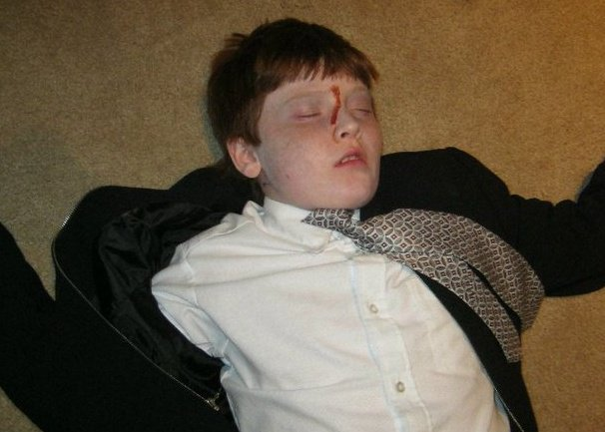
Figure 1: Phoenix’s picture for his memoir titled “My Deadly Vacation”
Writing Sample #1
My Deadly Vacation
Have you ever almost killed your mom and your self twice in one week, well I have. The second my mom told me that we were going to Hawaii I was immediately filled with glee. Then my mom told me that her friend Constance was coming the glee I had was immediately gone like a balloon in the breeze. A few weeks later we get on the plane and our seats are who would have guessed right near the bathroom ten smelly hours later we arrive.
As we got off the plane I smelled the fresh Hawaiian air my mom went and hugged some complete stranger to me at least my mom told me it was her friend Drew. Fast forward to the first near death situation. So we were going scuba diving and I didn’t know what was in the suspicious waters of Hawaii so as I got in to the strange green waters I hung on to my mother for dear live and don’t be super critical I was like 7. As I stayed holding my mother she started to sink and so did I and what made it worse there was coral scratching my legs like a cat would scratch a sofa. When I got out of the horror movie that most people call a vacation I was so happy I was away from there. Later that day as I was thanking god that I didn’t drowned my mom told me we were going to some Hawaiian version of the Grand Canyon I was the something canyon but it was a canyon don’t you worry. So I was complaining because of the whole near death thing. So as my punishment I was taken to the top of the canyon and grabbed by my feet and hung over the guard rail after that I shut up. Fast forwarding to the next near death scenario.
WARNING: THE PURE RAW AWESOMENESS OF THE NEXT FRAGMENT OF THE STORY IS SO AWESOMELY UNBELIVEABLE THAT IT MAY MAKE YOUR HEAD EXPLODE READER DISCRETION IS ADVISED.
As I sat cramped in a compact car with a full grown man a pregnant woman and my mom I was a sardine in a can. To add to the awkwardness we were on the bumpiest road in America. So we get off of bump road and we see this awesome beach coolest ever so I grab my mini surf board thing and go into the water then mom decides to help me we were a few feet out in the water and we are facing land we see all the people on land waving frantically at us but by then it was to late I was immediately engulfed in a monster 10 foot wave I am stuck under the water then monster wave #2 hits then I get up and monster wave #3 hits by this time I am totally out of breathe I feel a hand grab me and I wonder Jesus? No it was not Jesus it was my mom coming to help me so as I dragged my limp body up to shore I heard the sound of the crashing waves they were laughing at me. I was confused as to why people call this a vacation for me it has been a tropical horror fest lets review I was stuck on a stinky plane, cut by coral, almost dropped off a canyon and got beat up badly by 10 foot waves, but it has been one of the greatest weeks of my life. Wow, this is defiantly a vacation I will never forget.
Reflection
During lesson one of the memoir project Phoenix (a pessimistic, witty, AIG sixth grader) sat with his computer screen in front of him saying he had nothing to write about because his life was not interesting. During this fist session he spent most of his time changing his glog’s appearance rather than working on his timeline, his poor use of time or writer’s block is evident in the lack of number of events in which he listed on his glog. After being asked to find some pictures of important events or moments in their lives, Phoenix had an idea for writing. He chose this picture from Halloween because it reminded him of his near death experiences.
Phoenix’s writing definitely has style and the author’s voice is easily heard throughout. The picture prompted Phoenix’s writing and forced him to reflect on his life. Throughout his memoir, the reader is given a glimpse into his relationship with his mother. He speaks of his unhappy reaction when his learns his mother’s friend is going to Hawaii with them. He also speaks about his mother hugging a complete stranger and of being held above the canyon by his feet. In the last paragraph we learn more about Phoenix. In spite of his near death experiences, he had the best week of his life.
When his mother came to school for Phoenix’s independent conference, she was impressed by his memoir. She kept saying how his writing sounds like an author she really enjoys reading and even shares some books with Phoenix. She was impressed with Phoenix’s use of voice in the writing. She also commented on his frequent use of description and the amount of figurative language he used.
I feel sure Phoenix’s writing would have suffered had the photography lessons about framing not been taught. I feel he would have breezed through his photo collection without using his imagination and adding more to the picture. Getting a coherent story actually written on paper using Phoenix’s own, unique voice demonstrates growth shown through this project.

Writing sample #2
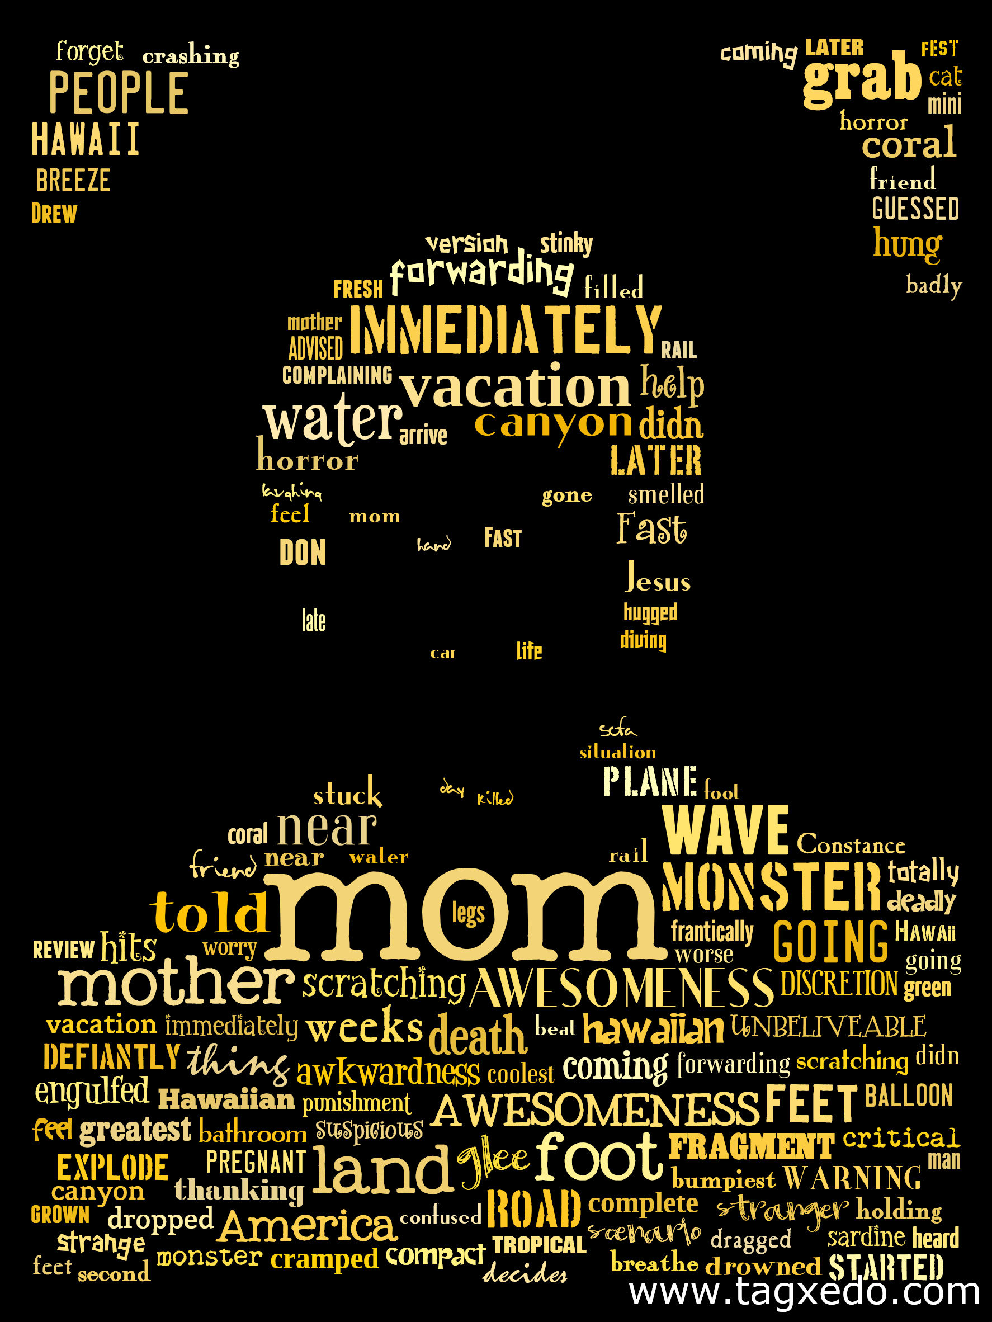
Figure 3: Phoenix’s Memoir Shape Poem
Phoenix was asked to create a shape poem using his silhouette. He used words from his memoir to create the design. More important words from his memoir were made larger and more noticeable. From his poem, mom is the biggest word. His memoir was really about his mom, according to this poem. Phoenix got started on this writing right away without hesitation which is atypical for him. I believe this happened because he was very proud of the way his memoir turned out and this writing assignment was an extension of it. He was also motivated to use the online Tagxedo tool to help him create the poem.
Student #2
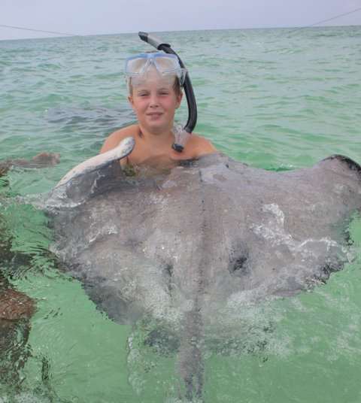
Figure 3: Ben photograph for his memoir titled Cayman Islands Vacation
Writing Sample #1
Cayman Islands Vacation

Screeeech I heard the sound of the air plane wheels hitting the ground on the Cayman Islands. The Cayman Islands are in the British West Indies. When we got off the plane my dad and Kenny (is my dads friend that came with us and Kenny’s family came to) went to get the jeeps that sat there quietly waiting to be driven. Then we pulled out of the air port we almost got hit by a car because we were driving on the wrong side of the road because there you drive on the left side of the road.

When we go to the house we were staying at I couldn’t believe my eyes it was beautiful because the sand was white and the water was so clear it was on the beach and there was a pool on the sides of the pool were these huge rocks and the whole back yard was the beach there were conk shells (conk shells are huge shells like the ones you can buy at a gift shop) every where I just knew this was going to be the best trip ever. I thought the house was a castle. The first two days it rained so we couldn’t do that much. After that we went to a place called rum point. It was so awesome there were so many fish and we saw some sting rays and me and my friend Drew caught a star fish that looked like a small octopus. Then we swam out I little father and started to see conk and we started to put them together but after a while they crawled away. Then we had to go catch them. After that we ate lunch then headed home for the day. The next morning we were going fishing so that night we set our alarm clocks to the time the TV said but at the time we didn’t know that it was set on Miami time so we woke up an hour early. So we got dressed then we just watched TV for 30 minutes until it was time to go. When we got to the pier it was about five o clock we waited for the captain for about five minutes then he pulled up in his boat we loaded our coolers then headed off we didn’t go that far off shore but we caught a ton of fish we caught mostly caught tuna except some barracuda. My dad told me to keep my eyes on the horizon so I wouldn’t get sea sick then the captain asked me to come up and sit with him up top of the boat it was really cool because you could see every thing. Then we started to see some flying fish jump that was really cool considering I have never seen a fish fly before. Then we dropped the lines and started to catch fish. When my brother started to reel in a barracuda my friend Cayman got scared because he thought if you were out of the water the barracuda would still bite you if you were wearing any thing shiny so he was asking my dad were he should put his necklace because he thought he was going to get bit. The fish felt like they were a cinder block but in reality they weight about 7-12 lbs. They were really fun to real in because I have never caught a fish that big before. Then once we had caught seven or eight we headed back to shore once we got there the chef made us garlic bread and sushi made out of the tuna we had caught. While I was eating the garlic bread a chicken jumped up in my lap and took the bread and flew off. It scarred me to death all a saw was a bunch of white feathers. After finishing eating that we headed back to the house.

When we got back to the house it was about time for lunch we had ham sandwiches then we went swimming in the ocean. The water is crystal clear so you can see really well. When we got out there we saw this huge mound of coral with fish coming in and out of it. Me and my dad saw this huge barracuda as soon as my dad saw it he put his watch in his pocket because barracudas are attracted to any thing that is shiny. After that I swam back in as fast as I could. When I got back in I started to try to fish for the barracuda with a spinner bait that had a treble hook. I didn’t get a bite I never saw the barracuda for the rest of the trip considering I never swam out that far for the rest of the trip.

The next day we rented a sail boat to take a tour on. It was huge it had a kitchen I circular booth A bench on one wall and a bedroom. The part I liked the best was that you could walk on the deck and go sit on the tip of the boat. The first stop was sting ray city when we got about I fourth of a mile away I started to see them from that distance they looked pretty small but when we dot closer they were as big as me they were huge it was really freaky because I didn’t know they got that big and when we started to pull up to the sand bar the 2nd mate jumped over board and hooked the anchor then he swam over to one of the rays and grabbed it. Then we all jumped in each of us got a turn holding the sting ray it was pretty cool. We also got to feed the sting rays some type of fish. When they swam over to eat it the sucked in the fish they didn’t grab it. We forgot to bring the water proof camera so we didn’t get to take pictures of the rays under water. Once we all got back in the boat the next stop was the barrier reef I have to say that that was my favorite part it was really cool. That was the biggest piece of coral it was a purple blue color. There were all kinds of fish once we dove under I saw more fish than I could imagine lived in one place my favorite fish was the parrot fish it was the coolest fish I have ever seen it actually had a beak and the colors were like I reel parrot it was about the size of a medium sized dog it was really pretty. Then I started to dive deeper and in the sand were these huge shells when I picked one up I was heavier than I thought it would be I grabbed it and swam to the surface my dad said it was a conk. It was the biggest shell I have ever seen. Inside there were these little knife looking thinks that the conk use to pull them selves along the bottom so they are no very fast. I went back to the reef and I saw a nurse shark it was awesome. The captain who was diving with us told me to come here he pointed to a huge lobster the tentacles were about I foot and a half long I didn’t know lobsters got that big. Then we saw a moray eel it only had one eye it really creped me out. Then it was time to go back to shore that was one of my most favorite part of the trip.
Once we got back I made me and my dad made sushi witch the chef at the dock taught me how but mine wasn’t nearly as good as the chef’s. But it was really fun to make because each piece only cooked for about five seconds. We also had grilled and fried tuna and barracuda. I ate that like a pig because I love fish. I now have a new favorite fish.
Then the next day we started to pack up because the week was coming to and end. Right after lunch we started our drive back to the airport we dropped off our luggage. My dad and Kenny gave the jeeps back to the rental place then we got on the plane and headed back home. As then plane took off I thought to my self I will never forget this trip ever.
Reflection
Ben is a hardworking student who is performing right at grade level in Language Arts. Ben loves to hunt and fish. He reads a lot of Gary Paulson books because he gets to read about things he likes. Throughout the course of this assignment, I struggled to help Ben reflect on why this experience shaped who he is. I would have liked to see more reflection in his memoir. The only time reflection is evident is when he talks about his love for fish and he says he will not forget the trip.
I like the way Ben includes the story behind the photograph into his memoir. Without the picture, he may have forgotten details like including the second mate jumping out of the boat and forgetting the under-water camera. In my opinion, this is the best paragraph in the whole memoir. Asking him to think about framing and what happened before the photograph helped Ben to add thoughtful details to his memoir. Ben’s memoir is more successful than his other writings because he learned to add these details.

Writing Sample #2
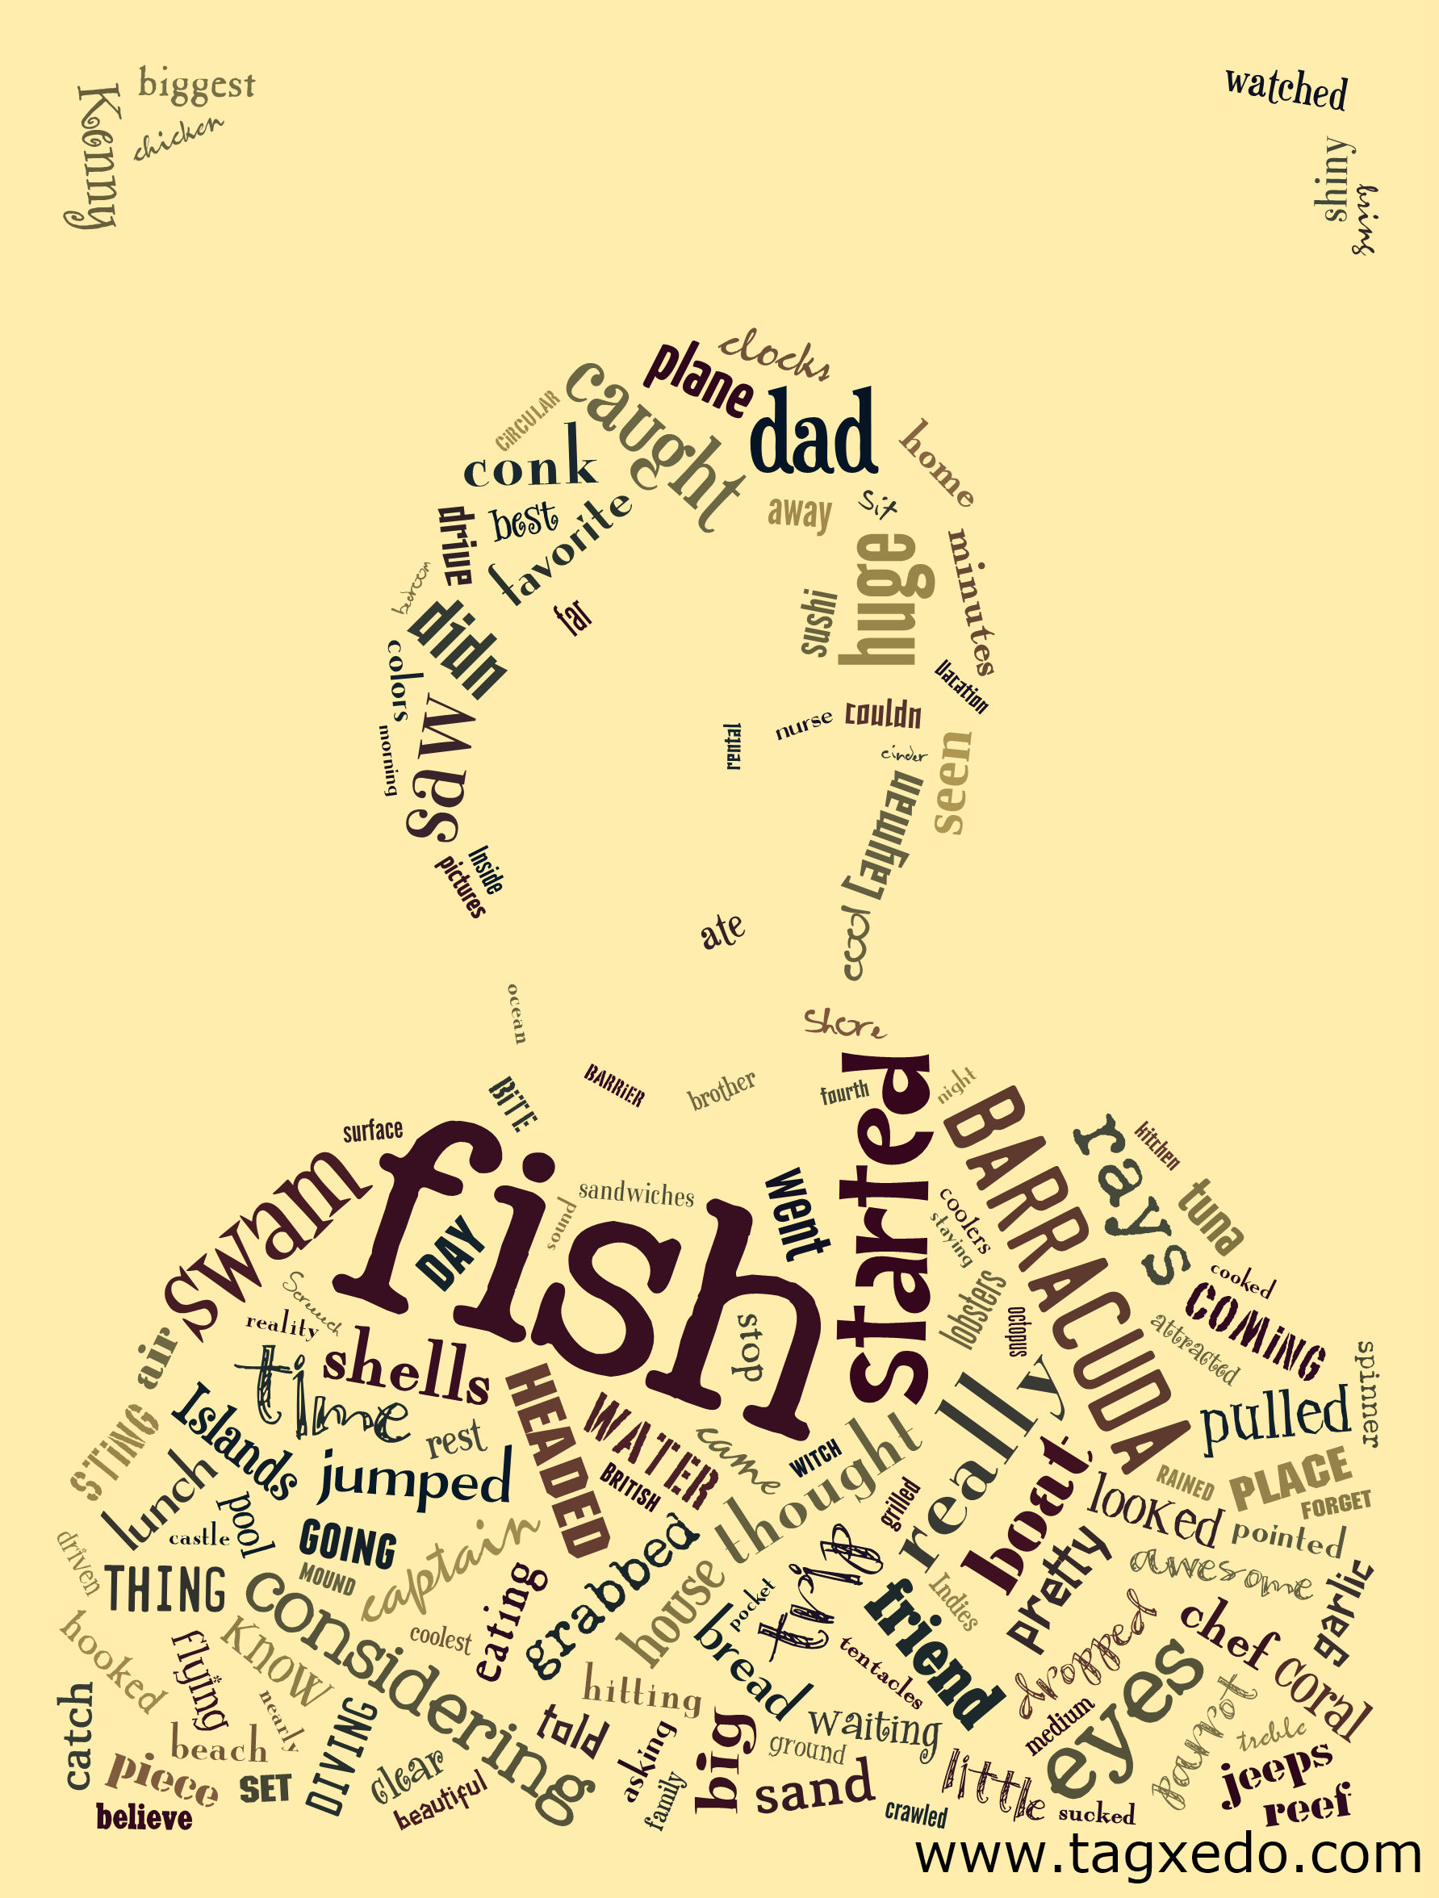
Figure 4: Ben’s Memoir Shape Poem
Ben’s shape poem includes the words from his memoir he wanted to use. Obviously, the word fish is the biggest since this memoir is about his love of it. I also like how dad is at the top of his head. Ben did an excellent job of choosing significant words from his memoir to add to his shape poem.
Student #3
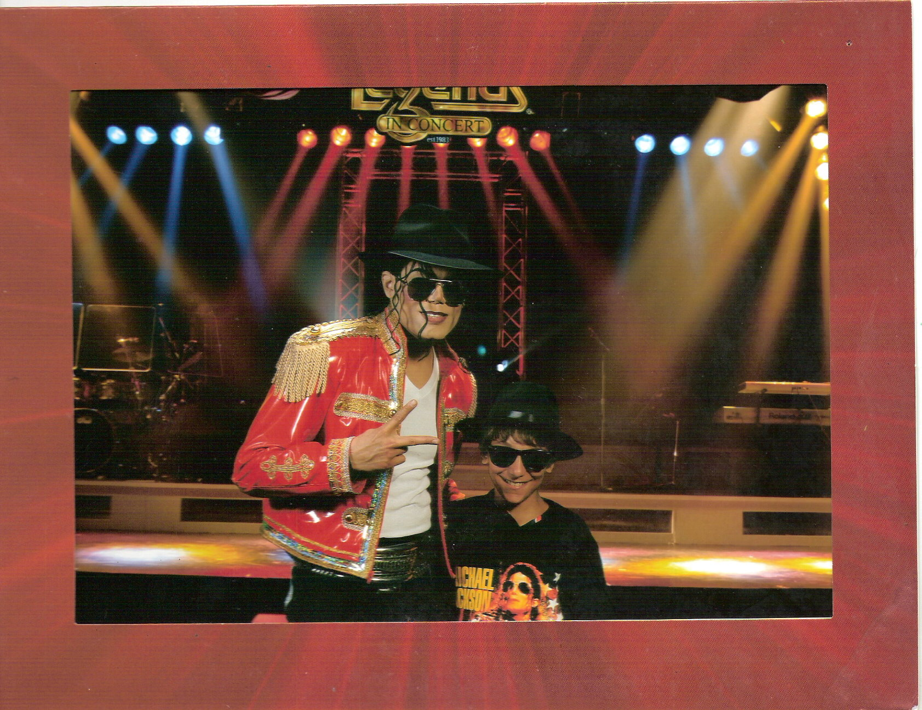
Figure 5: Alex’s photograph for his memoir titled “My Day with Damion Brantley, the Great King of Pop Impersonator
My Day with Damion Brantley, The great King of Pop Impersonator
“Because it’s Thriller” Damion yelled across the rusty old Legends in concert stage doing the moonwalk as I slurped my coke and chomped my candy. It was a great day for me June 14th at South Carolina Myrtle Beach 2010 seeing famous singers like Buddy Holly, Elvis Presley, Beatles, Blues Brothers and even the Great king of pop, Michael Jackson impersonators. Before and even after the show I got a chance to chat with Damion who looked sounded and even moved like the real Jackson. I also got to get his signature and even a photograph with Him. Me and my family went back to the beach house that we stay in every year with me singing Jackson’s greatest hits with me as well gliding across the deck with a Jackson Shirt and glasses. On our way back to North Carolina, We asked ourselves, “Why did that day we went to Legends have to be so short.” “We were so lucky we got to see his very last show before he left for Vegas” I stated aloud. The following day, I went home and added Damion on Facebook, and you should have seen the look on my face when he accepted my friend request. I was so happy I couldn’t fall asleep that night, and from that day forward I was known as to like Jackson and his greatest hits. Later I looked up MJ games on Google, there was a dancing game to where you can dance like him and boy will I buy it when It comes out. “It will be fun” I stated myself.
Reflection
Alex is a student performing below grade level in reading. He is reading on a fourth grade level and has limited experience with print. This year, I have seen him abandon more books than he has read. His writing is usually the same. He is one of the students who groan when it’s time for writer’s workshop. This assignment was different for Alex, he was eager to share the story behind the photograph he chose. He had a beginning, middle, and end and his ideas were liked together by the topic. I was impressed with the lead in his memoir and the details about the concert hall, no doubt coming from the photograph. We also learn that Alex became known for his passion for Michael Jackson because of that trip. Getting Alex to share with me was an accomplishment.
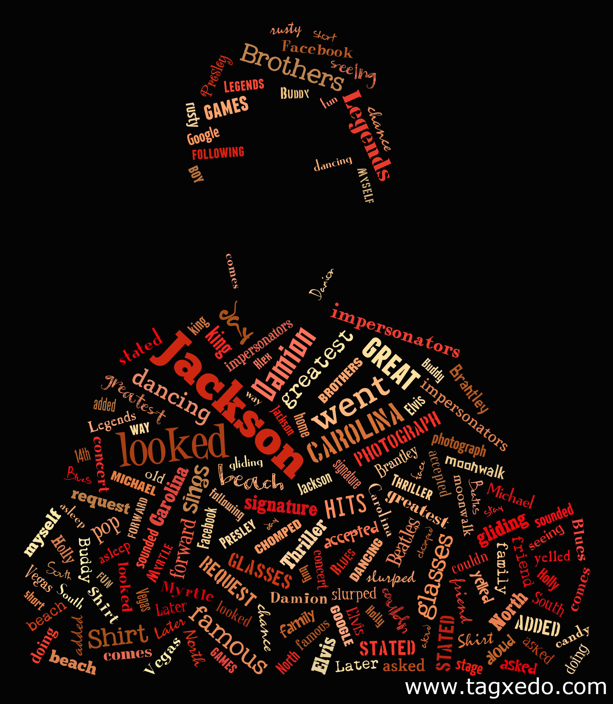
Figure 6: Alex’s Memoir Shape Poem
Reflection
Alex chose to make Jackson’s font large to make a point about the topic of his paper. He also included words that were significant to his memoir. He was engaged in class because he was able to use the editing software and use an online publishing tool.

